California Early Learning Career Lattice (Career Lattice) – Educational Requirements
The Career Lattice defines a progression of roles and the training and education necessary to demonstrate competence in a wide variety of positions in early learning. It identifies a common framework through which professionals can evaluate their progress towards their own career goals. The Career Lattice is a guide to help professionals in the early learning field to think about their career path and professional development. The Career Lattice does not change any of the existing regulations or licensing requirements for working in a child care center, infant/toddler program, preschool, family child care home, or TK-third grade teacher or early childhood program administrator. To learn more about the Career Lattice please read the California Early Learning Career Lattice Guide at https://www.cde.ca.gov/sp/cd/ce/documents/caelcareerlatticeguide.docx.

Understanding the Structure of the Career Lattice (please see Appendix, p. 9)
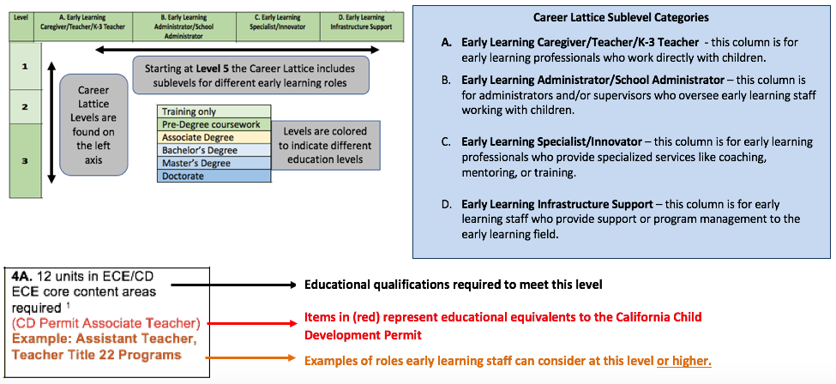

California Early Learning Career Lattice – Educational Requirements
Level | A. Early Learning Caregiver/Teacher/K-3 Teacher | Levels 1-4 do not have any subcategories. The space below includes important notes and considerations for each level.
1 | 8 hours of training in health & safety and/or child development.  Example: On-boarding to lattice for family, friend and neighbor care providers | Level 1 is a point of entry for people interested in working in the early learning field. At this level 8 hours of training on health and safety and/or child development is needed. This is a good starting point for people who have been providing informal care and are interested in pursuing a role in a family child care home or preschool.  Local Resource and Referral agencies are a recommended starting point for finding training on health and safety or child development.
2 | Current Family Child Care Licensing Requirements  Example: family child care provider | Level 2 is set at current licensing requirements for family child care providers. Currently this level requires 16 hours of health and safety training in addition to training on signs of child abuse. This is the minimum amount of training required for family child care homes.  Visit the DSS Resources for Providers website at http://www.cdss.ca.gov/inforesources/Child-Care-Licensing/Resources-for-Providers to learn more about family child care provider requirements and resources.
3 | 16 hours of health & safety training and mandated reporter training  + 45 hours of training (state-approved and/or Resource & Referral agency training)  OR  3 semester (4.5 quarter) units of ECE/CD/HD  Example: family child care provider | Level 3 is a point where people should consider transitioning from training to college coursework. This level is a bridge from family child care entry requirements to meeting requirements for working as an aide in licensed preschool.  The majority of people choose to attend child development classes at their local community college. Usually 3 semester units are earned through a single child development class. Some colleges and universities in California operate on a “Quarter” system and 3 semester units is equivalent to 4.5 quarter units.  See the Career Lattice Guide for more information on taking courses.
4 | 6 units in ECE/CD  (CD Permit Assistant Teacher)  Example: Teacher aide | Level 4 is equivalent to the first level (Assistant) of the California Child Development Permit. At this stage it is important to be taking the “Core” courses which include: child/human growth & development; child/family/community or child and family relations; and programs/curriculum. Completing these units provides a beginning foundation in child development and is required as one moves up the Career Lattice.

Level | A. Early Learning Caregiver/Teacher/K-3 Teacher | B. Early Learning Administrator/School Administrator | C. Early Learning Specialist/Innovator | D. Early Learning Infrastructure Support
5 | 5A. 12 units in ECE/CD  ECE core content areas required  (CD Permit Associate Teacher)  Example: Title 5 Assistant Teacher Title 22 Teacher | 5B. 12 units in ECE/CD + 3 units in administration or staff relations  ECE core content areas required  Example: Center Director- Title 22 Child Care Centers | Level 5 does not have sublevel for Early Learning Specialist/Innovator or Early Learning Infrastructure Support. It does have a sublevel for administrators which includes a course in administration or staff relations  At this level it is important to be taking general education (GE) course along with child development courses. | Level 5 does not have sublevel for Early Learning Specialist/Innovator or Early Learning Infrastructure Support. It does have a sublevel for administrators which includes a course in administration or staff relations  At this level it is important to be taking general education (GE) course along with child development courses.
6 | 6A. 24 units of ECE/CD + 16 semester units of GE  ECE core content areas required  (CD Permit Teacher)  Example: Teacher Title 5 or Title 22 | 6B. 24 units of ECE/CD + 16 semester units of GE, ECE core content areas required + 3 units in administration or staff relations Example: Center Director- Title 22 Child Care Centers | Level 6 is the first level where GE courses are required. GE courses must include: one course in each of four general education categories, which are degree applicable: English/Language Arts; Math or Science; Social Sciences; Humanities and/or Fine Arts. | Level 6 is the first level where GE courses are required. GE courses must include: one course in each of four general education categories, which are degree applicable: English/Language Arts; Math or Science; Social Sciences; Humanities and/or Fine Arts.

Associate Degree
AA=Associate Arts Degree
AA-T*= Associate Arts Transfer Degree
AS=Associate of Science Degree
AS-T*=Associate of Science Transfer Degree
*Transfer Degrees are for California Community College students and are designed to provide a clear pathway to the CSU degree major.
It is important that students contact their local community college for information on meeting the requirements for an AA-T or AS-T degree.
Level | A. Early Learning Caregiver/Teacher/K-3 Teacher | B. Early Learning Administrator/School Administrator | C. Early Learning Specialist/Innovator | D. Early Learning Infrastructure Support
7 | 7A. AA/AA-T/AS/AS-T in ECE/CD  OR  AA/AA-T/AS/AS-T with 24 semester units in ECE/CD  OR  60 units including 24 units of ECE/CD and 36 units of GE  Example: Teacher, Head Teacher | 7B. AA/AA-T/AS/AS-T in ECE/CD OR AA/AA-T/AS/AS-T with 24 semester units in ECE/CD + 3 units in administration or staff relations OR 60 units including 24 units of ECE/CD and 36 units of GE, 3 of which are in administration or staff relations Example: Center Director- Title 22 Child Care Centers | 7C. AA/AA-T/AS/AS-T in any field with 24 semester units in ECE/CD  Example: Administrative assistant working at a First 5, County Office of Education, Resource and Referral Agency, or community agency | 7D. AA/AA-T/AS/AS-T in any field  Example: Administrative assistant working at a First 5 or community agency

Baccalaureate Degree
Level | A. Early Learning Caregiver/Teacher/K-3 Teacher | B. Early Learning Administrator/School Administrator | C. Early Learning Specialist/Innovator | D. Early Learning Infrastructure Support
8 | 8A. ECE Content  Baccalaureate degree in ECE/CD  OR  Baccalaureate degree in any discipline with 36 semester units of ECE/CD, including 18 semester units of upper division coursework.  Examples: ECE Lead Teacher or Site Supervisor  OR  Multiple Subject Teaching Credential with 24 units ECE/CD Examples: K-12 or Transitional Kindergarten (TK) teacher  OR  Early Childhood Special Education Credential Examples: Infant/Toddler, preschool, TK or K teacher focused on children with special needs | 8B. Administrator  Program Director Permit  OR  Baccalaureate degree or higher with 15 units of management/administration/ supervision/leadership /policy including 6 administrative units, 2 adult supervision units and 24 units of ECE/CD including coursework related to serving infants and toddlers.  OR  Administrative Services Credential with 24 units ECE/CD  Examples: Title 5 program director or director mentor/coach | 8C. ECE Support  Baccalaureate degree in any field with 24 semester units in ECE/CD Example: Staff person working at a community agency (R&R, First 5, County Office of Education) supporting an early learning initiative, ECE coach, trainer, or technical assistance specialist.  OR  Pupil Personnel Services Credential  Example: School psychologist | 8D. Support  Baccalaureate degree in any field  Examples: Staff person working at an R&R, First 5, County Office of Education, or community/state agency providing administrative support to a quality improvement initiative

Master’s Degree
Level | A. Early Learning Caregiver/Teacher/K-3 Teacher | B. Early Learning Administrator/School Administrator | C. Early Learning Specialist/Innovator | D. Early Learning Infrastructure Support
9 | 9A. ECE Content  Master’s degree in ECE/CD  (CD Permit Program Director)  OR  Master’s degree in any discipline with 36 semester units of ECE/CD, including 18 semester units of graduate level coursework.  Examples: ECE Lead Teacher or Site Supervisor | 9B. Administrator  Master’s Degree in any field plus a Program Director Permit  OR  Master’s degree in any field plus Administrative Service Credential  OR  Master’s degree or higher with 15 units of management/administration/ supervision/leadership /policy including 6 administrative units, 2 adult supervision units and 24 units of ECE/CD including coursework related to serving infants and toddlers.  Examples: Program director of multiple sites (Title 5) , director mentor/coach, ECE trainer, CA Community College faculty | 9C. ECE Support  Master’s degree in any field with 24 semester units in ECE/CD  Examples: Coordinator of a quality improvement initiative like QRIS, First 5 program officer, coach or technical assistance specialist. | 9D. Support  Master’s Degree in any field  Examples: Program coordinator at a community agency, researcher, staff at an advocacy organization.

Doctorate
Level | A. Early Learning Caregiver/Teacher/K-3 Teacher | B. Early Learning Administrator/School  Administrator | C. Early Learning Specialist/Innovator | D. Early Learning Infrastructure Support
10 | 10A. ECE Content  Doctorate or Post-Doctoral study in ECE/CD  Examples: Faculty at a college or university in baccalaureate and/or graduate studies programs. | 10B. Administrator  Doctoral degree with 15 units of management/administration/ supervision/leadership /policy including 6 administrative units, 2 adult supervision units and 24 units of ECE/CD including coursework related to serving infants and toddlers. | 10C. ECE Support  Doctorate or Post-Doctoral study with 24 units in ECE  Examples: ECE faculty at a college or university in baccalaureate and/or graduate studies programs. | 10D. Doctorate  Doctorate or Post-Doctorate in any subject  Example: Researcher or public policy expert.

Appendix: Understanding the Structure of the Career Lattice
The image on page 1 represents a section of the career lattice showing an example of levels 1 through 3, and vertical and horizontal arrows indicating how the lattice is organized. Career lattice levels are found on the left axis. Levels 1-4 do not have sublevel categories (education categories). Starting at level 5, the career lattice includes sublevels for different early learning roles.

The education sublevel categories are:

- Early Learning Caregiver/Teacher/K-3 Teacher: early learning professionals who work directly with children

- Early Learning Administrator/School Administrator: administrators and/or supervisors who oversee early learning staff working with children

- Early Learning Specialist/Innovator: early learning professionals who provide specialized services like coaching, mentoring, or training

- Early Learning Infrastructure Support: early learning staff who provide support or program management to the early learning field.

An image of cell 4A from Level 5 on page 5 is an example of the kind of information found in each cell. The first information in each cell indicates the educational qualifications required to meet the level; the information in parentheses represents educational equivalents to the California Child Development Permit; information beginning with the word “example” are examples of roles early learning staff can consider at this level or higher.
California Department of Education
August 2018

Required ECE courses include: child/human growth & development; child/family/community or child and family relations; and programs/curriculum. You must have a minimum of three semester units or four quarter units in the core areas of child/human growth & development and child/family/community.
GE courses must include: One course in each of four general education categories, which are degree applicable: English/Language Arts; Math or Science; Social Sciences; Humanities and/or Fine Arts.

