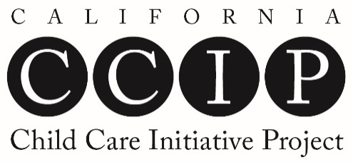
Participant Training Record
(Use this chart to track completion of CCIP workshops)

First Name | Last Name | CA ECE Registry ID (9 digits)

TRAINING DATE | CCIP TRAINING TITLE | Number of hours completed in each  CA ECE Competency Area |  |  |  |  |  |  |  |  |  |  |  | CCIP STAFF  MEMBER NAME | AGENCY PROVIDING CCIP TRAINING
 |  | CDL | CDE | RIG | FCE | DLD | OSAD | SNI | LEC | HSN | LECE | P | AS

California Early Childhood Educator Competency Areas Abbreviation Key
CDL | Child Development and learning | DLD | Dual-Language Development | HSN | Health, Safety, and Nutrition
CDE | Culture, Diversity, and Equity | OSAD | Observation, Screening, Assessment, and Documentation | LECE | Leadership in Early Childhood Education
RIG | Relationships, Interactions, and Guidance | SNI | Special Needs and Inclusion | P | Professionalism
FCE | Family and Community Engagement | LEC | Learning Environments and Curriculum | AS | Administration and Supervision

CCIP Training Outline - based on the CA ECE Competencies

(Effective date: July 1, 2017)

Child Development & Learning

Knowledge about Child Development & Learning

Facilitating Child Development & Learning

Culture, Diversity, & Equity

Respect for All Differences & Similarities

Culturally Responsive Approaches

Culture, Language Development, & Learning

Culturally Inclusive Learning Environments

Relationships, Interactions, & Guidance

Supporting Children’s Emotional Development

Social-Emotional Climate

Socialization & Guidance

Family & Community Engagement

Communication with Families

Relationships with Children & Families

Community Resources

Dual-Language Development

Dual-Language Program Models & Strategies

Development of the Home Language & of English

Observation & Assessment of Young Dual-Language Learners

Relationships with Families of Dual-Language Learners

Observation, Screening, Assessment, & Documentation

Observation

Screening & Referral

Assessment

Documentation

Interpretation, Planning, & Implementation

Special Needs & Inclusion

Philosophy, Policies, & Practices

Developmentally & Individually Appropriate Practice

Collaboration with Families & Service Providers

Environmental Access & Adaptive Equipment

Learning Environments & Curriculum

Curriculum & Curriculum Planning

Environments, Schedules, & Routines

Strategies to Support Learning & Development

Health, Safety, & Nutrition

Environmental Health & Safety

Emergency Preparedness

Nutrition

Response to Health Requirements

Child & Family Health

Physical Activity

Leadership in Early Childhood Education

Systems & Change Development

Adult & Community Development

Advocacy & Policy Formation

Professionalism

Professional Development

Professional Conduct & Behaviors

Competence in a Specialized Body of Knowledge

Pedagogy

Administration & Supervision

Program Planning, Development, & Operations

Human Resources

Organizational Systems, Policies, & Procedures
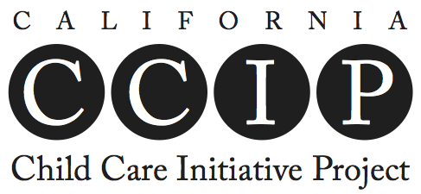
The California Child Care Initiative Project (CCIP) provides training and ongoing support to licensed family child care providers, assistants, and individuals seeking to obtain a license. The goal of the project is to improve the quality of care for children in all family child care (FCC) homes, especially infants and toddlers.

Training is intended to provide CCIP participants with a good foundation of knowledge to support their success as well-rounded caregivers, early childhood education professionals, and FCC business owners.

To attain Trainee status, participants must complete a minimum of 25 hours of CCIP training.

On the right is a list of the CCIP training topic areas which are based on the California Early Childhood Educator Competencies.

Use the chart on the other side of this sheet to track CCIP training that has been completed.

CCIP is a statewide quality improvement project, available in every county in California in every Child Care Resource & Referral program. CCIP is funded by the California Department of Education, Early Education & Support Division (CDE, EESD).
For more information, visit www.rrnetwork.org/ccip
For more information, contact:
LOCAL CCR&R CCIP CONTACT INFORMATION HERE
(DELETE ORANGE TEXT)
Insert: AGENCY LOGO/PHOTO HERE
Photo copy this document front to back on one sheet of legal-sized paper (8.5” x 14”)
(DELETE ORANGE TEXT)

