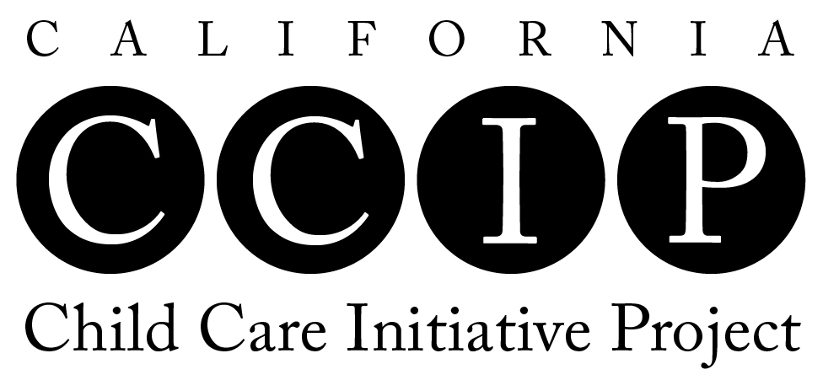

PROJECT PLAN: Training Timeline
Fiscal Year 2016 – 2017

CONTACT INFORMATION: Person completing the Training Timeline

Agency Name:

County:
Contact Name:
Email:
Phone:

List training information as indicated in the chart below. Include projected training date, training topic, language(s) of training, presenter name, training format (e.g., workshop, home study, home visit, one-on-one, online), and number of training hours by CCIP Module area. Each CCIP contractor is required to provide a minimum of 25 hours of agency training during the contract year. Please see the Training Guidelines in the CCIP Policies and Procedures prior to completing this timeline. Add rows as needed.

DATE | TRAINING TOPIC | LANGUAGE(S)  OF TRAINING | PRESENTER | FORMAT | NUMBER OF TRAINING HOURS BY MODULE AREA
 |  |  |  |  | M1 | M2 | M3 | M4 | M5  (I/T)
8/15/16 | Young Children & Brain Development | English | Maria Fuerte | Workshop |  |  | 1.5 |  | 1.5

DATE | TRAINING TOPIC | LANGUAGE(S)  OF TRAINING | PRESENTER | FORMAT | NUMBER OF TRAINING HOURS BY MODULE AREA
 |  |  |  |  | M1 | M2 | M3 | M4 | M5  (I/T)
TOTALS

