SECTION ONE: INTRODUCTION
SUB-SECTION 1.1: CA Early Learning and Development System
ACTIVITY 1
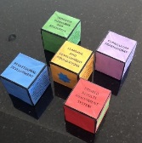  Sort  Put together  Take apart  Group  Pattern  Categorize  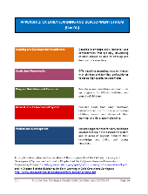  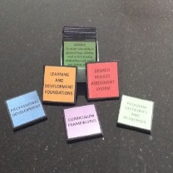  Analyze  Compare  Connect | WHAT CAN YOU TELL US ABOUT THE CA EARLY LEARNING AND DEVELOPMENT SYSTEM?  - What is the CA Early Learning and Development System?  - What are the components of the CA Early Learning and Development System?  - What is the purpose of each component of the CA Early Learning and Development System?  - What does that have to do with me as a provider?

RATIONALE FOR THIS ACTIVITY
Licensed family child care providers are more than just business owners and operators. It is important for these individuals to understand the context in which their businesses operate and the various roles they are expected to assume in their day-to-day professional life (e.g., qualified and knowledgeable professional, program leader, strategic thinker and planner). It is also important for them to know and understand that there is a support system in place that can help them succeed in the early care and education field. This activity provides an opportunity for participants to start learning about the system and what the system offers.
Activities 2 and 3 in Section One explore the system further, connecting the various components and allowing the participants to reflect on how the system can support them, as providers, as well as the learning and development of the children in their program.
SECTION TWO: FEASIBILITY
SUB-SECTION 2.2: Market Research
ACTIVITY 1
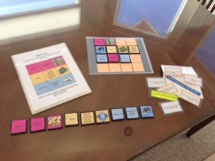  Sort  Put together  Take apart  Group  Pattern  Categorize  Analyze  Compare  Connect | WHAT CAN YOU TELL US ABOUT MARKET RESEARCH?  - What is market research?  - What are the elements of market research?  - What are some examples that illustrate each element of market research?  - What does that have to do with me as a provider?

RATIONALE FOR THIS ACTIVITY
Market research is instrumental in determining the feasibility of a business idea, shaping the services to be provided, and developing business sustainability. It is important for prospective and operating licensed family child care providers to understand that their businesses will not, or do not operate in a vacuum; that there are elements within their immediate context that will impact them, either positively or negatively; and that there are ways to minimize the negative impacts and maximize the positive ones. This activity provides an opportunity for participants to learn what those elements are and the concept they represent.
Activities 2 and 3 in sub-section 2.2, Market Research, explore the connection between market research and the viability and sustainability of a family child care business, as well as how local resource & referral agencies can be a resource to prospective and operating family child care providers interested in conducting market research.
SECTION THREE: STEPS TO BECOMING LICENSED
SUB-SECTION: Fingerprints
ACTIVITY 2
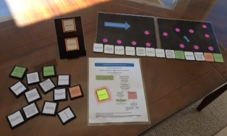  Sort  Put together  Take apart  Sequence  Map  Analyze  Connect | WHAT CAN YOU TELL US ABOUT THE FINGERPRINTING AND BACKGROUND CHECK PROCESS?  - What is the first step in the background check?  - What are possible outcomes of the background check?  - What happens when the Dept. of Justice denies an exemption?

RATIONALE FOR THIS ACTIVITY
All individuals applying for a family child care license and all the other adults residing in the home shall be fingerprinted and obtain a California criminal record clearance or exemption. It is important for prospective licensed family child care providers to understand that the Department of Social Services will not issue a license without the proper clearance. It is also important for operating providers to know and understand that this regulation applies to any new adults who start residing in the home. This activity provides an opportunity for participants to learn about the background check process that takes place after the adults residing in the home are fingerprinted.
Activity 1 in sub-section 3.3, Fingerprints, aims to locate and explore basic information about fingerprinting requirements when applying to become a licensed family child care provider.

SECTION FOUR: BUSINESS PLAN DEVELOPMENT
SUB-SECTION 4.1.2: Operating Budget
ACTIVITY 2
$10 $10  $10 $10  $10 $10  $10 $10  $10 $10  $10 $10  $10 $10  $10 $10  20 + 110 – 100 = 30  20 + 30 – 40 = 10  10 + 30 – 50 = -10  -10 + 50 – 10 = 30 | WHAT CAN YOU TELL US ABOUT OPERATING BUDGETS?  - What is an operating budget?  - What are revenues/income?  - What are expenses?  - An example that illustrates the concept of profit is …  - An example that illustrates the concept of cash flow is …  - An example of negative cash flow is …  - What does that have to do with me as a provider?

RATIONALE FOR THIS ACTIVITY
Operating budgets are predictions of all the revenues and expenses that a business is expected to have over the course of a year. However, it is important for prospective and operating licensed family child care providers to understand that some ultimately profitable businesses may struggle to make ends meet and pay their expenses throughout the year because of cash flow issues. It is also important for them to know and understand that strategies such as quarterly cash flow predictions and comparisons to actual expenses can help prevent those issues. This activity provides an opportunity for participants to recall and define basic terminology and concepts associated with operating budgets.

