Backgrounder: Surgical Wait Times
- Starting in March 2015, wait times for surgeries across the province started increasing.

Waiting more than 3 months:
- The number of people waiting over three months for their surgery has tripled in just eleven months.
  - In Regina, the amount of people waiting more than three months for surgery has increased by 285%.
  - In Saskatoon, the amount of people waiting more than three months for surgery has increased by 120%.

 | All Regions | Saskatoon | Regina
Feb -15 | 4641 | 2628 | 1834
Jan - 15 | 4100 | 2396 | 1528
Dec – 15 | 3650 | 2175 | 1357
Nov – 15 | 3134 | 1940 | 1126
Oct – 15 | 3182 | 1937 | 1156
Sept – 15 | 2900 | 1831 | 971
Aug – 15 | 2561 | 1623 | 836
Jul -15 | 2191 | 1409 | 671
Jun – 15 | 1804 | 1237 | 482
May – 15 | 1767 | 1232 | 478
Apr – 15 | 1720 | 1192 | 484
Mar- 2015 | 1693 | 1201 | 469

Waiting more than 6 months:
- The amount of people waiting more than 6 months for surgery has increased by 174%.

A shifting trend:
- Up until March 2015 wait times were decreasing, and now we see a dramatic increase. Rates are increasing at a faster rate than they were decreased in the last few years.
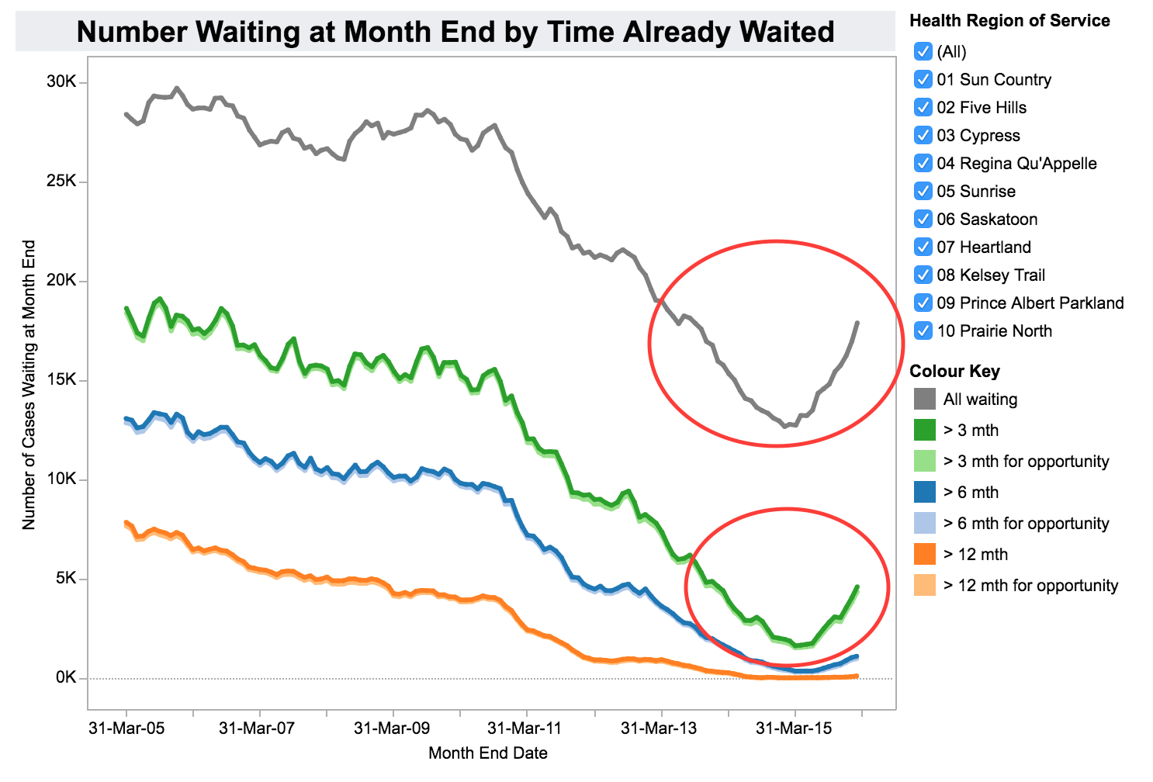
Graph retrieved from: http://www.sasksurgery.ca/tableau/waitingmonthend.html

