The Australian Society for the Study of Labour History
welcomes you to the
Harold Peden Memorial Lecture 2017
“Spring Cleaning: It’s time to dust off state union rules”
Guest Speaker: Tony Beech, Trade Union Advocate and Retired Chief Commissioner, WAIRC
With the State Government announcing a review of the State IR system,
Tony will talk about the importance of unions checking that their
State Union Rules are up-to-date.
About the Speaker:
Tony Beech was the first President of the SSLHWA in 1987.
He had first worked for the unions with the FEDFU in 1973 until 1976. After a time overseas, he worked for the ETU 1978 to 1982, then at the FMWU from1982 until his appointment to the WAIRC in 1988.
He was also the President of the TLC 1987 – 1988. Last year he retired from the WAIRC as Chief Commissioner.
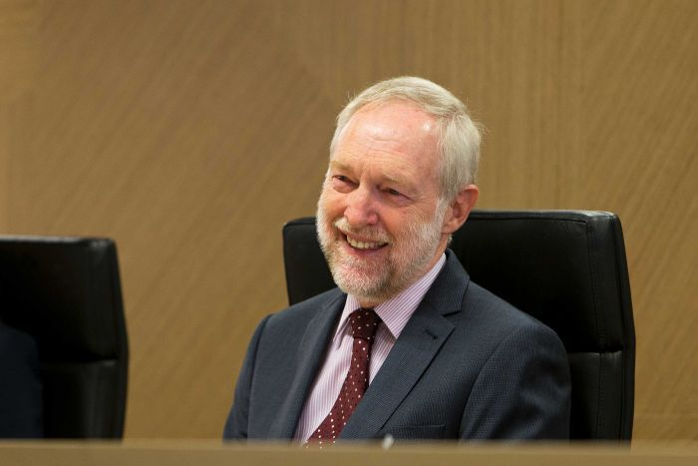
Thursday 16 November 2016
6:00 pm for 6:30 start
CSA Building, Level 6, 445 Hay Street Perth
A light supper will be provided
The Working Voices Choir will also perform.
The event is free to attend but registrations are required for catering purposes.
RSVP: Neil Byrne 9349 8153 or Nadia Nelson at UnionsWA 9328 7877 admin@unionswa.com.au

About Harold Peden
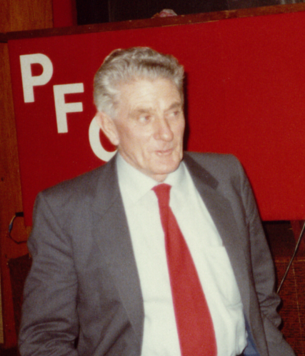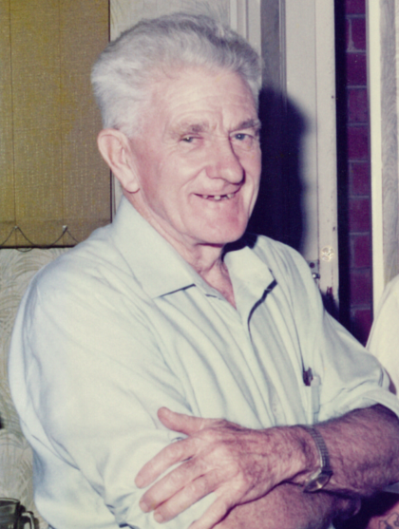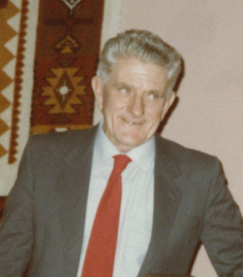
Harold Peden was a senior trade union activist, State President of the Amalgamated Metal Workers Union, Senior Vice President of the Trades and Labor Council, State President of the Communist Party of Australia and a long-time activist in the peace movement, retiring in July 1985.
Each year since his untimely death in 1993 due to boating accident, Labour History celebrates Harold’s life with a community lecture emphasising his work and passion. Harold Peden was a man who took the cause of labour and labour history to his heart.
A political activist and proud unionist throughout his working life, Harold was awarded the Order of Australia in 1990 for his services to the trade union movement and Western Australian workers.

