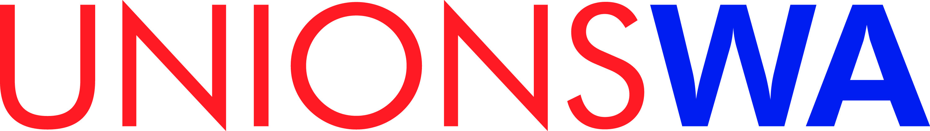

Industrial Officers Network Conference 2019
Date: Thursday, 7 November 2019
Time: 8:30 am – 4:30 pm followed by conference drinks & networking
Venue: 6th Floor, Walkington Room, 445 Hay Street, Perth

For more information please contact Tim Dymond at tdymond@unionswa.com.au and please email completed forms to the same email address.

SPONSOR ENROLMENT FORM & TAX INVOICE (when paid)
DETAILS
Name of Organisation:
Contact person:
Email:
Mobile:

Sponsorship amount:
Number of attendees: (See overleaf for names if known)
Do any attendees have dietary or special requirements? (yes)
details:

PAYMENT Method
1. Electronic Funds Transfer | 2. Credit Card | Mastercard or Visa only | 3. Invoice
Funds to be transferred to: | Name as printed on card: |  | To be sent to:
BSB: 066 000 | Card Number:
Account No: 11870182 | Expiry Date: (mm/yy)
 | CVV:
 | Amount: $ (inc gst)
 | Signature:

UnionsWA Incorporated. ABN: 64 950 883 305
4th Floor 445 Hay Street Perth, PO Box Z5380 St Georges Tce Perth WA 6831
Ph: 08 9328 7877 www.unionswa.com.au
Name of Attendee | Dietary or special requirements?

