Lois A. Hardesty
Thursday, March 09, 1944 - Friday, August 28, 2015

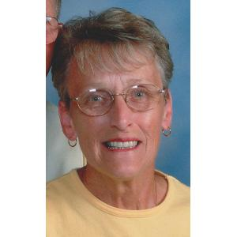
Lois A. Hardesty, 71, of Normal, formerly of Danvers, died at 10:25 p.m. on Friday, August 28, 2015 at Advocate BroMenn Medical Center in Normal.
A memorial mass will be held at 10 a.m. on Wednesday, September 2, 2015 at St. Mary’s Catholic Church in Bloomington, with Rev. Ric Schneider officiating. Inurnment will immediately follow services at Park Hill Cemetery, Bloomington. Visitation will be from 5 to 7 p.m. on Tuesday at Carmody-Flynn Funeral Home, Bloomington. Cremation rites will be accorded after visitation. In lieu of flowers, memorials may be made to CISAR. To express condolences online, please visit www.carmodyflynn.com.
She was born March 9, 1944 in Bloomington, daughter of Cecil and Mildred Warner Hill. She married Harold L. Hardesty on February 23, 1963 in Bloomington. He preceded her in death on September 29, 2014. She was also preceded in death by one brother, Robert.
Surviving are three sons, Bart (Lisa) Hardesty of Glen Ellyn, Brad Hardesty of San Francisco, CA and Brent Hardesty of Chicago; two grandchildren, Quinn and Katie Hardesty of Glen Ellyn. Also surviving are two sisters, Carolyn McNeely and Joyce Thorpe.
She retired from Funks Seeds-GrowMark, where she worked as a registered seed technician.
Lois enjoyed spending her free time with family and friends, and she especially loved the time spent with her grandchildren.

