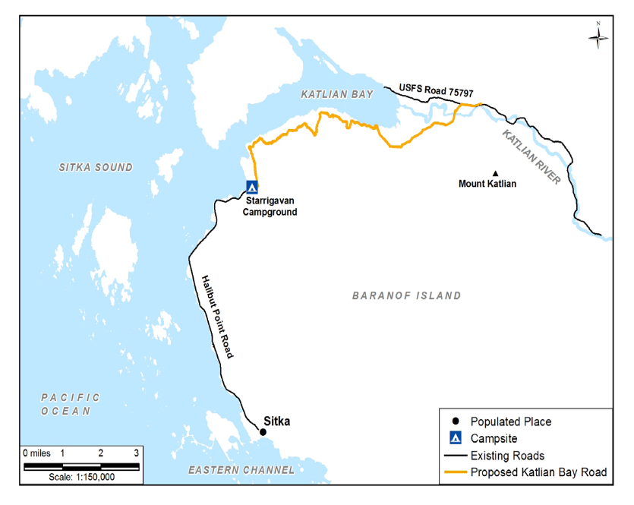
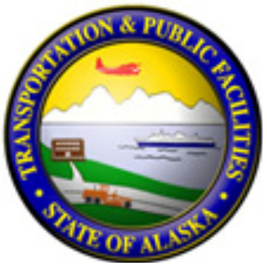
ALASKA DEPARTMENT OF TRANSPORTATION AND PUBLIC FACILITIES
KATLIAN BAY ROAD

PROJECT DESCRIPTION

The project would result in the construction of approximately 9 miles of new single lane, unpaved road with bridge crossings beginning at the northern terminus of Halibut Point Road, extending east along the south shoreline of Katlian Bay to cross the Katlian River, and terminating 4 miles east of the Katlian Bay estuary at the boundary between Shee Atika and U.S. Forest Service (USFS) lands.

The new Katlian Bay Road would provide recreational and subsistence opportunities on Baranof Island area within the USFS Sitka Ranger District, provide access to Native Corporation (Shee Atika) lands, and may also provide access to material sources for possible future development.

ROAD FEATURES
The DOT&PF is proposing a road design that would:
• Begin at the northern end of Halibut Point Road
• Terminate at a new USFS trailhead at USFS Road No. 75797
• Have a speed limit of 25 mph with approximately
100 turnouts and 2-foot shoulders
• Include viewpoints along road and an end point comprising parking area, fire ring,
and restroom
• Include about 55 culverts, 6 arch culverts, and 5 bridges
• Include a bridge crossing of the Katlian River.

CURRENT STATUS
The project is currently in engineering
design and environmental review
status with construction projected
for late 2016.

CONTACT INFORMATION
Deborah Holman
Project Administrative Coordinator
DOT&PF Southcoast Region
P.O. Box 112506
Juneau, AK 99811-2506

Email comments to:
katlianbayroad@alaska.gov

It is the policy of the Alaska Department of Transportation and Public Facilities (DOT&PF) that no person shall be excluded from participation in, or be denied benefits for any and all programs or activities we provide based on race, religion, color, gender, age, marital status, ability, or national origin, regardless of the funding source including Federal Transit Administration, Federal Aviation Administration, Federal Highway Administration and State of Alaska Funds. The DOT&PF complies with Title II of the Americans with Disabilities Act of 1990.

