Solar hot water and/or Heat pump hot water tender for Southern Tasmanian Household Bulk Buy
8th December, 2017

Introduction
Sustainable living Tasmania is a not-for-profit organisation. For decades, we have been assisting Tasmanians to improve their energy efficiency through information, advice, assessments and upgrades. Through our new social enterprise website Eco Home Guide, we are partnering with reputable Tasmanian businesses to offer products and services. Our aim is for win-win-win-win scenarios… Customers receive sound advice, and great products/services at good prices; our partners receive more business and enhanced reputations; we receive commissions to help fund our other important work; and Earth's ecosystems get a little less pressure on them thanks to resulting energy, material, and greenhouse gas reductions.

One approach we take is community bulk buys: By pooling the purchasing power of residents we are able to offer lower prices on quality products and services. In 2015/16 we held a successful bulk buy on heat pumps with 400 expressions of interest resulting in over 120 sales, and excellent feedback from customers.

Southern Tasmanian Household Bulk Buy
We are now partnering with the Southern Tasmanian Councils Authority to deliver a series of bulk buys on a number of energy efficient products over 2017/2018.

Products offered in the bulk buys will include heat pumps, insulation and LED downlights, solar panels and batteries, solar hot water and heat pump hot water. Additional products are currently under consideration.

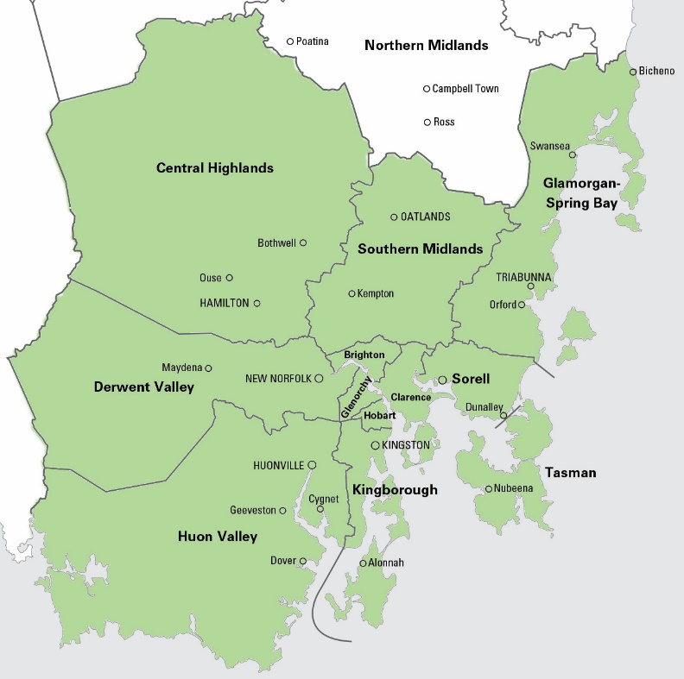
Only premises within participating council areas are eligible for the bulk buys:
- Brighton
- Central Highlands
- Clarence
- Derwent Valley
- Glamorgan Spring Bay
- Glenorchy
- Hobart
- Huon Valley
- Kingborough
- Sorell
- Southern Midlands
- Tasman

We are working with each of the councils to promote the bulk buy extensively. We have access to:
- Marketing opportunities through all southern Tasmania councils, with a population of over 255,000
- >8,000 members and supporters on our database
- >7,000 likes on our Facebook page
- ~5,000 users per month on our websites (average)

Supplier selection process
We are holding a tender process to select supplier/installer(s) of solar hot water and/or heat pump hot water systems for the bulk buy. We may choose one supplier/installer to do both system types (solar and heat pump), one supplier/installer for each type, or possibly one supplier to do just one type and exclude the other type from the bulk buy (if we do not receive a satisfactory tender offer for one of the types).

The process timeline is as follows:

Date | Milestone
8th December | Tender open
10th January | Tender closes
17th January | Successful tenderer(s) selected
24th January | Contract signed
12th February | Bulk buy registration opens
30th March | Bulk buy registration closes

While the tender open and close dates are final, other dates may be subject to change.

Process for each customer
- Customer requests a quote through our Eco Home Guide website within the bulk buy registration period for the product in question (see indicative dates in the table above).
- We promptly forward the customer’s details to the supplier by email, and also add them to an online spreadsheet that the supplier has shared access to.
- The supplier contacts the customer and provides an indicative quote by phone or email for supply and installation of the product(s).
- The customer confirms interest with the supplier.
- The supplier performs a site visit and provides a firm quote.
- The customer confirms the purchase by paying a deposit (or the whole amount) to the supplier within the validity period of the quote (nominally 2 months).
- The supplier installs the product at a time agreed with the customer.
- We survey the customer about their experience.

Supplier’s responsibilities
The supplier will be required to:
- Contact customers as quickly as possible (nominally within a week) after they have requested a quote.
- Attempt to contact customers more than once, including by phone.
- Update the shared online spreadsheet as the process with each customer progresses.
- Provide products and installations at the agreed pricing for all eligible customers who request a quote within the registration period.
- Provide standard prices (not the discounted bulk buy price) to customers who aren’t eligible (e.g. not located within the participating councils).
- Perform high quality installations in a professional manner, and clean up thoroughly before leaving site.
- Communicate in a timely manner and work together with us to tackle any challenges as they emerge.
- Be available to present / answer questions at a public workshop that we organise to promote the bulk buy and help potential customers make an informed decision about which product (if any) is right for their situation.
- Pay a commission to Sustainable Living Tasmania each month on completed sales.
- Not contact bulk buy customers about matters unrelated to the bulk buy (e.g. newsletters or other sales offers) without their prior express permission.
- Maintain customers’ privacy.
- Use staff and contractors with relevant experience and qualifications to perform the task and adhere to workplace health and safety standards.

Our responsibilities
We will:
- Conduct marketing and promotional activities, in coordination with participating councils
- Maintain the Eco Home Guide website to provide accurate information on the products and services, and receive quote requests.
- Provide and maintain a shared online spreadsheet to track progress of customers.
- Promptly after receiving a quote request, forward customers’ details to the supplier by email, and add them to the shared online spreadsheet.
- Survey customers about their experience, and provide feedback to the supplier, participating councils, and customers.
- Communicate in a timely manner and work together with the supplier, participating councils, and customers to tackle any challenges as they emerge.

Quantity and pricing
Please fill in the attached Tender Offer with pricing that you can offer us. We will determine the price for customers by adding a small commission to help cover our costs and support our mission as a registered charity. We will keep our margin low in order to pass on maximum savings to customers. The customer price will be promoted to residents, with the supplier selling to eligible customers at these prices. We will invoice the supplier monthly for commissions on completed sales.

Given 120 sales resulted from our 2015/16 heat pump bulk buy, we expect a similar number from this bulk buy. However, this information is provided as a guide only - we cannot guarantee a minimum quantity, and so the tenderer should factor any risk of lower sales into their offer.

Product/service specifications
This tender is specifically for installing solar hot water and/or heat pump hot water systems. While the initiative is targeted at households, businesses and other organisations may also choose to participate. Ideally, a small number of standard packages will be offered. For example, this may include two or three different storage volumes to cater for different hot water demands.

Products should be from reputable manufacturers and have good warranties.

TENDER OFFER

Contact details (for us to contact you about the tender offer)
Person’s full name:
Position:
Mobile phone number:
Email address:

Business details (public contact details)
Business name:
ABN:
Website:
Phone number:
Email address:
Do you have one or more showrooms? If so, where?

Experience
How long has the business been in operation in Tasmania?

Solar hot water (leave blank if not offering solar hot water)
How long has the business been installing solar hot water in Tasmania?

Approximately how many installations of solar hot water systems in Tasmania has the business done in the past 12 months?

Heat pump hot water (leave blank if not offering heat pump hot water)
How long has the business been installing heat pump hot water systems in Tasmania?

Approximately how many installations of heat pump hot water systems in Tasmania has the business done in the past 12 months?

Quality assurance
Briefly describe administration systems and processes you use to ensure good customer service and smooth operation of your business:

Briefly describe measures you take to ensure quality installation:

Briefly describe measures you take to ensure safety, including installers relevant qualifications and accreditations:

What relevant insurance policies does your business hold (please include $ limits)?

Products

Specifically which product(s) (makes/models) do you propose to offer for the bulk buy?

What are the particular benefits of these products over competing products?

Please attach any relevant product information (e.g. technical specifications, promotional brochure, material safety data sheet)

Please provide details of warranties offered for the components of the system(s) you are offering.

Capacity
Briefly describe how you would handle an increased volume of quote requests if the interest in the bulk buy was particularly high:

At what rate (customers per week) can you install the product?

Briefly describe how you would handle an increased volume of installations if the interest in the bulk buy was particularly high. If you would engage sub-contractors, please describe past experience working with sub-contractors:

Deposit
What percentage of the overall purchase price would you require customers to put down as a deposit?

Pricing

Solar hot water
Make | Model | Description | Product information attached (yes/no) | Number of STCs system attracts (for installation in Hobart based on 2018 install, i.e. 13 year period) | Price offered to us for bulk buy  product only, before STCs ($ excluding GST) | Standard installation price* ($, ex GST)

Heat pump hot water
Make | Model | Description | Product information attached (yes/no) | Number of STCs system attracts (for installation in Hobart based on 2018 install, i.e. 13 year period) | Price offered to us for bulk buy  product only, before STCs ($ excluding GST) | Standard installation price* ($, ex GST)

* Variations on installation
We understand that some installations will cost more than others. Please provide a schedule of charges for non-standard installations below:

Item | Price offered to customer ($, ex GST)
Additional travel beyond km of Hobart

How to submit your Tender Offer
Complete the form and attach to an email along with any supporting information to michele@slt.org.au by 10th January 2018.

Further information
If you would like more information, or to discuss specific details, please contact:
Michele Matthews
Partnerships Manager
(03) 6281 9375 (Mon, Tue, Thurs)
Email: michele@slt.org.au

For businesses using SimPro we have developed an integration that automates this process.

