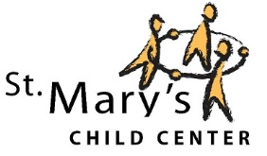

**We are inspired by the Reggio Emilia Approach, and offer a diverse, unique experience for children and their families.**

**Now Enrolling**

**2020-2021**

**Teacher/Student Ratio 7:1**

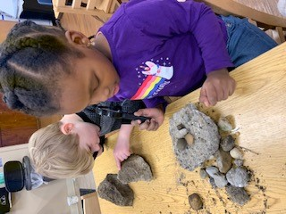

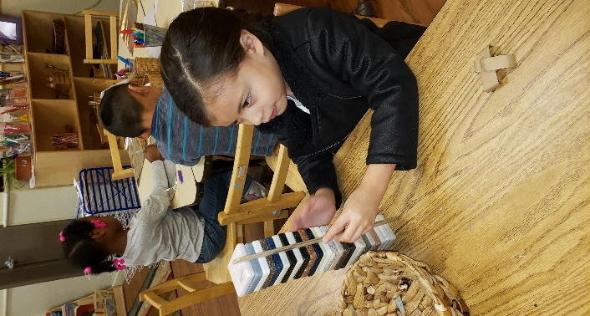

**St. Mary’s Child Center   
has the highest level of quality, Level 4, serving children 3 to 5 years old.**

***We accept Tuition, CCDF and On My Way Pre-k***

***St. Mary’s Scholarships Available***

**Breakfast, Lunch and Afternoon Snack included**

**All supplies included**

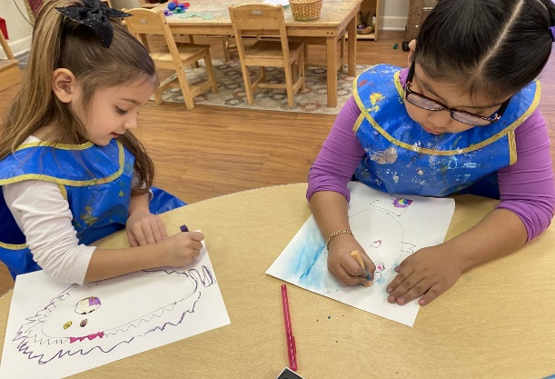

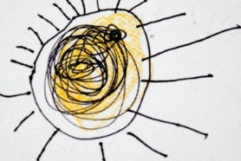

***Call 317-635-1491 with questions and to schedule a tour***

Four locations in Marion County:

•Downtown Indianapolis •Ft. Harrison •IPS-Butler Lab School •St. Anthony’s•

