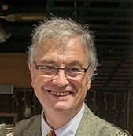
Iain Brodie Browne- one of the four that went in search of Big Ideas for SLF book published in 2018
- Councillor first elected 1984 re-elected (again) 2017-served as Group Leader and Cabinet member
- SLF Council member elected 2 years ago
- Fought 4 parliamentary elections including Southport 1983
- Chief Exec and founder of NW Mental Health Charity Imagine Independence (just retired after 40 years)
- Served on Liberal Party Standing/Policy Committee and ALC Standing Committee
- Political Vice Chair of NLYL 1974/5
- Chair Radical Youth for Europe 1975-7
- Veteran of many national and community campaigns
- Other publications incl: Road to Wigan Beer, Liberals and Welfare part of the Liberty 2000 project to review 1983 General Election which I chaired
- Tweets @onebsquared
- Blogs at http://birkdalefocus.blogspot.com/
Keen to continue with the development of radical ideas. My priorities are a second collection of essays, setting up regional meeting and campaigning with other likeminded radicals to provide a viable political alternative

