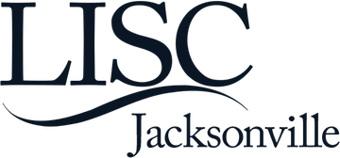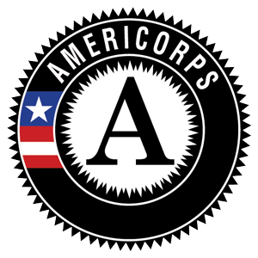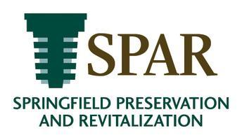

AmeriCorps Member Service Opportunity
Part-Time Position 900 hours in 10 months
Springfield Preservation and Revitalization (SPAR) and Local Initiatives Support Corporation are seeking a full-time AmeriCorps member to serve as a Community Engagement Coordinator. The candidate will ideally begin service on October 1, 2019 and serve a minimum of 900 hours though the end of his/her term on July 31, 2020. The exact start and end date is confirmed by the Member Agreement of Participation. The individual selected to serve is not considered to be an employee of SPAR or LISC.

ORGANIZATION BACKGROUNDS
SPAR was formed in 1974 to provide leadership to the residents of Springfield, a National Historic District in Jacksonville, Florida, to revitalize, preserve, and restore the community through programs focused on historic preservation; quality of life; community engagement; commercial corridor revitalization; and civic advocacy.
With residents and partners, LISC forges resilient and inclusive communities of opportunity across America – great places to live, work, visit, do business and raise families. Over the last 38 years, LISC and its affiliates have invested approximately $20 billion in businesses, affordable housing, health, educational mobility, community and recreational facilities, public safety, employment and other projects that help to revitalize and stabilize under invested communities. These investments have leveraged more than $50 billion in development activity and helped families and communities raise their standards of living. LISC investments impact the lives of nearly 7 million Americans. Headquartered in New York City, LISC’s reach spans the country from East coast to West coast in 31 markets with offices extending from Buffalo to San Francisco. Our rural programs make an impact in 44 states, and are supported by LISC’s talented and dedicated workforce. Visit us at www.lisc.org .

AMERICORPS MEMBER ACTIVITIES AND RESPONSIBILITIES
SPAR relies on community volunteers to expand the capacity of our organization to implement diverse programs designed to improve quality of life in the Springfield Historic District. The Community Engagement Coordinator will advance SPAR’s work to engage and activate theses volunteers. The Coordinator will help design, build and implement several volunteer engagement programs.
ESSENTIAL FUNCTIONS of the position include:
Collaborate with staff and volunteer leaders to plan and implement volunteer program
Create stewardship activities that address needs and schedules of racially and economically diverse individuals and families
Conduct outreach activities to engage diverse individuals and organizations in activities
Collaborate with staff to refine and expand our volunteer programs to engage more residents in historic preservation and commercial corridor programs
Develop deeper community partnerships to support these programs
Design and implement a strategic volunteer recruitment plan
Serve closely with staff to recognize volunteer participants
Track data and evaluate programs
Complete and submit paperwork and reports in a timely manner

PERFORMANCE, CAREER DEVELOPMENT, AND SERVICE REQUIREMENTS
This is an AmeriCorps position. LISC and SPAR will not allow the member to engage in activities that are considered prohibited under the terms of the grant while serving as a LISC AmeriCorps member.
Members will be provided with goal(s) at the onset of the service assignment based on the activities and responsibilities noted above. Members will track goal attainment monthly through an on-line system (training provided). Members will also discuss professional performance in the form of a mid- term and final appraisal. Members are required to track time and submit on-line (training provided) time sheets twice per month.
Members will perform day to day service at the SPAR Council Office and serve a minimum of 20 hours per week. Normal service hours are Monday – Thursday from 9:00 am – 2:00 pm with 30 minutes for lunch per day. There will be opportunities to serve evenings and weekends.
Members will have an immediate supervisor and a local LISC supervisor throughout the term of service as identified by LISC and SPAR.
Members are expected to attend and participate in all LISC AmeriCorps sponsored activities including but not limited to:
❐ Attending a local on-boarding session coordinated by LISC and an onsite orientation to our organization;
❐ Attending a national leadership conference tentatively scheduled for March 2019;
❐ Attending all locally sponsored monthly meetings;
❐ Participating in nationally sponsored webinars;
❐ Actively participating in at least two team coordinated service projects (one for Dr. Martin Luther King, Jr. Day of Service and one for National AmeriCorps Week); and,
❐ Engaging in any other LISC events as determined by the local LISC office.
DESIRED SKILLS
❐ Desire and ability to work with a diverse group of people, particularly those living in low-income distressed neighborhoods
❐ Ability to work independently and in a team environment
❐ Computer skills
❐ Good written and oral communication skills
❐ Ability to work a flexible schedule (some night and weekends may be required)

PROGRAM ELIGIBILITY REQUIREMENTS
To be eligible to participate as a LISC AmeriCorps member the candidate must meet all eligibility requirements to serve as a National Service participant including but not limited to:
❐ Be eligible to earn 100% of the education award associated with this description
❐ Be eligible to perform the term of national service associated with this description
❐ Have unexpired proof of status as a US citizen or possess unexpired permanent resident status and be able to provide documentation as determined by CNCS during the pre-enrollment period
❐ Possess a high school degree, GED certificate or agree to achieve GED during the term of service
❐ Be at least 17 years of age (note there is no upper age limit)
❐ Be able to complete at the hours within the time frame of the service term and serve the full term

NATIONAL SERVICE CRIMINAL HISTORY SEARCH REQUIREMENT
If a candidate has a criminal record, it does not necessarily make a candidate ineligible for service. Only candidates who are subject to registry on the National Sex Offender Public Website or have been convicted of murder may not participate as an AmeriCorps member. Only candidates being offered and then accepting the position must consent to a search of the National Sex Offender Public Website, a State Level Criminal History Search and an FBI search. Consent is provided via the LISC AmeriCorps application. Candidates must be cleared by CNCS prior to the first day of service.

PROGRAM BENEFITS
Upon successful completion of the term of service, the member will be eligible for a $2,960 education award to pay off existing, eligible student loans or return to school. Members are eligible to place existing student loans (loans must qualify and not in a state of default) into AmeriCorps forbearance. The position pays a total stipend of $8,000. The stipend is taxable and paid in 20 equal checks twice a month from LISC. Direct deposit is required.
Additional benefits for alums can be found here: https://www.nationalservice.gov/special- initiatives/employers-national-service/alumni and information on Public Service Loan Forgiveness can be found here: https://studentaid.ed.gov/sa/repay-loans/forgiveness-cancellation/public-service.

HOW TO APPLY:
Please submit your resume via electronic mail (preferred) or regular mail with a cover letter to:
Kelly Rich
Executive Director
Springfield Preservation and Revitalization Council, Inc.
Jacksonville, Florida 32206
executivedirector@sparcouncil.org

We are committed to diversity and inclusion in the selection process.
This program is available to all, and we treat all persons without regard to race, color, religion, creed, gender, sexual orientation, gender identity, national origin, ancestry, citizenship status, age, marital status, veteran status, disability, genetic information, or any other characteristic or status protected by applicable federal, state or local law.

