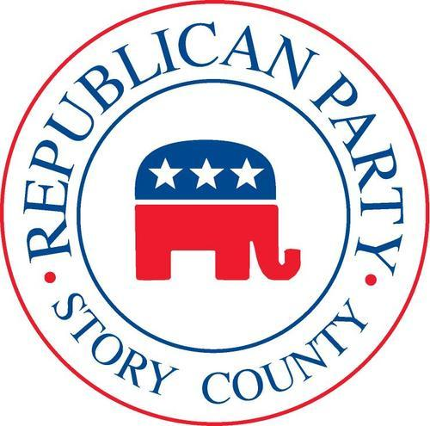

Monday, February 17, 2020
The Republican Party of Story County Convention will be held on Saturday, March 14 at 9:00 AM at the Talent Factory located at 1114 6th Street in Nevada.
The Story County Convention will conduct the following business:
- Elect 37 Delegates and 37 Alternate Delegates to the District Convention and State Convention.
- Create a County Platform
- Elect District Convention Committee Members
Please note the following important items:
Registration for the county convention will open at 8:00 am. Registration will close at 8:45 am so that alternates may be seated as necessary and the convention may begin promptly at 9:00 am.
Anyone interested in being a delegate to the district and state conventions MUST bring $75 on the day of the county convention in order to be certified as a delegate.
Republican Party of Story County Convention
Saturday, March 14, 9:00 AM
The Talent Factory
1114 6th Street
Nevada, IA 50201
The convention will be called to order by Brett Barker, who will serve as convention chair. Deborah Stoner of the Republican Party of Story County Central Committee will serve as convention secretary.
Please also note that amendments to the proposed Story County Republican platform must be submitted to the Credentials Committee prior to the opening of the Convention. Amendments must be typed or printed legibly and signed by at least ten delegates from three different precincts prior to submission.
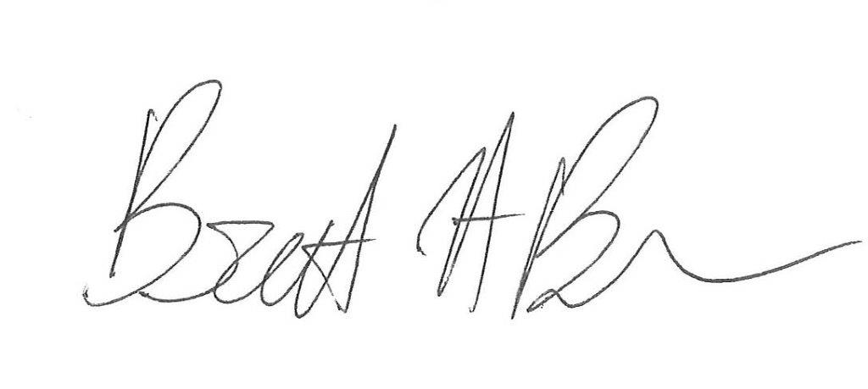
Brett Barker, Chairman
Republican Party of Story County

