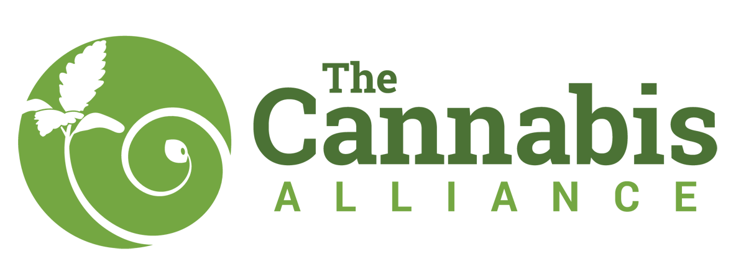
The Cannabis Alliance Membership Application

Applicant/Organization/Business Name:

UBI (if applicable): Type of Business:

Business Address:

Mailing Address:

Cell Phone: Business Phone:

Email: Membership Type:

Name of person completing this application:

Position with Business (i.e. Manager, Owner, etc):

Referred by:

Thank you for your interest in joining The Cannabis Alliance
The Cannabis Alliance is a non-profit, membership based association of individuals, businesses, government officials, and non-profit organizations dedicated to the advancement of a sustainable, vital and ethical cannabis industry. Through continuous development of our organization we agree ti think globally and act locally, committing our efforts to the access of safe quality cannabis for legal consumers in Washington State. Members will commit to the goals and protocols of membership when adopted and be accountable to the mission and bylaws of the organization.

Membership is subject to approval of The Cannabis Alliance and each application requires a minimum of one-month probationary period.

This application is not complete until payment is received. Please mail application and payment to:

The Cannabis Alliance
c/o Lara Kaminsky
3233 S. Hanford St.
Seattle, WA 98144

Applicant Digital Signature:

Date:

