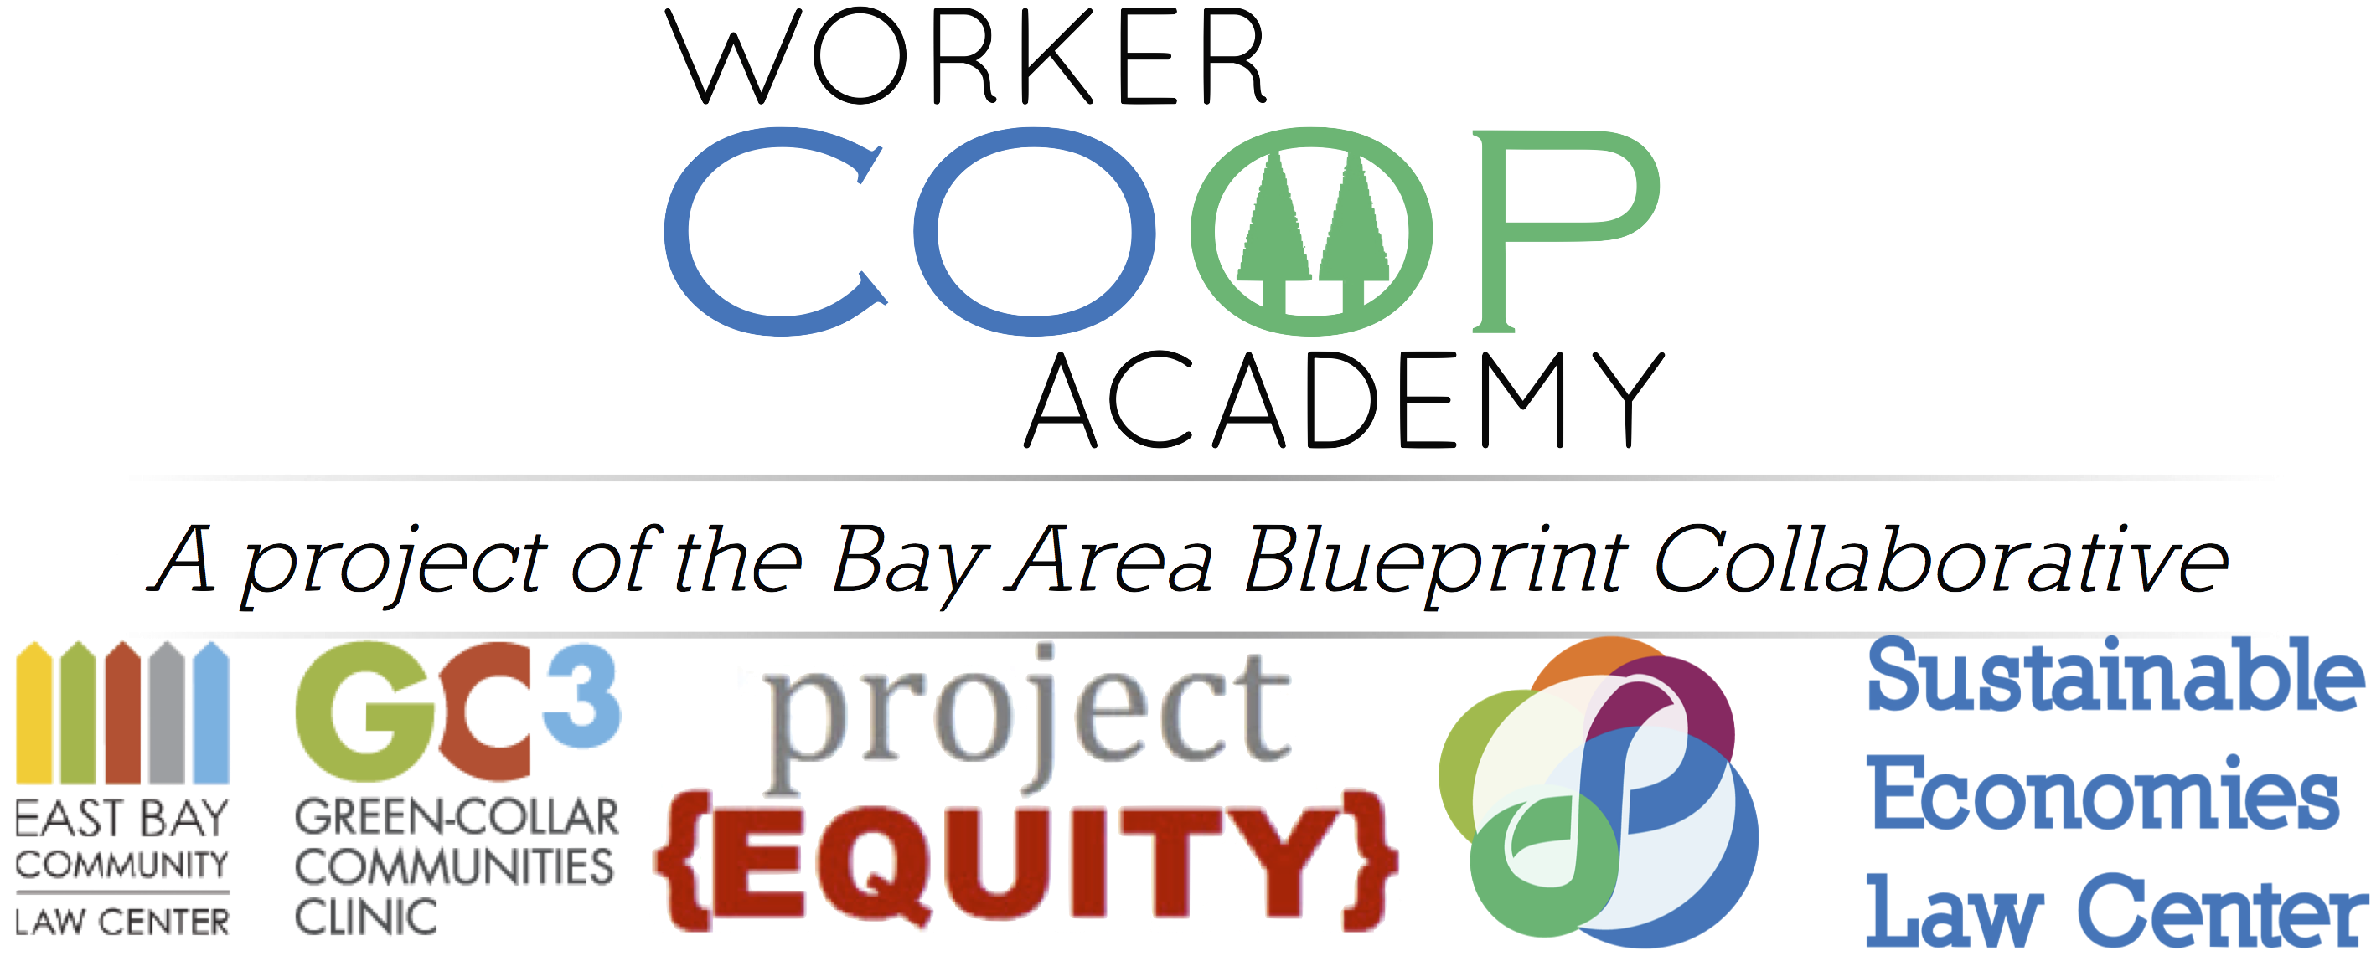

INVITATION TO APPLY
OPEN: May 5th, 2015
CLOSED: 11:59pm June 14th, 2015

Overview
The Worker Coop Academy, a program of the Bay Area Blueprint Collaborative, aims to assist the formation and expansion of worker-owned businesses that will provide good jobs for Low- to Moderate-Income (LMI) workers. The Academy will be held at Laney College in Oakland near Lake Merritt BART Station.
The Academy will provide assistance through multiple phases. During Phase 1, the Academy will provide a series of classes and workshops covering areas designed to help you start or grow a successful worker-owned cooperative business. These areas include business topics, management, workplace culture, cooperative development, and legal topics. This year, we are partnering with Centro Community Partners who will facilitate the business focused workshops. During Phase 2, the Academy will provide individualized business coaching and legal counsel for a subset of Phase 1 participants.

Participants
The Academy is designed for teams of no less than two (2) individuals who are working together to create or expand worker-owned cooperative businesses that provide good jobs for low- to moderate-income workers in the Bay Area. Our goal is to help you realize your vision of launching or expanding a successful, worker-owned business.

We have listed four categories of potential Academy participants below:
- Startup: Founders of new worker cooperatives that are in their start up phase or plan to open in 2015 or 2016.
- Expand: Members of existing worker coops that are seeking to strengthen their business for growth.
- Convert: Owners and employees looking to transition an existing business to worker ownership.
- Develop: Coops that are being developed by a nonprofit or other organization that are already operational or will open in late 2015 or 2016. Developers must have at least two workers of the incubating coop as participants in the Worker Coop Academy along with at least one staff member of the developer.

The main factors we are looking for in a successful applicant team are:
- Strong potential for business success and job creation for low- to moderate-income workers;
- A high likelihood of putting the Academy training to use in the near future; and
- Strong teamwork and shared vision.

Program Structure
Our goal is to help you realize your vision of building a cooperative enterprise and to add value to what you are already doing.

In Phase 1, we provide each team the following:
- Core workshops attended by all participating teams;
- Additional workshops in priority areas for your team;
- Mentoring by a successful local coop; and
- One to two personalized advice sessions focused on business or legal topics of critical importance to your business.

A subset of teams will advance to Phase 2 based on their demonstrated commitment and the potential for our intensive business coaching and legal counsel to add value at this stage in their business.

Curriculum
The Academy curriculum addresses the core components of developing and growing a successful worker cooperative capable of creating good jobs for low- and moderate-income workers. These components are:
- Governance, management and leadership;
- Financial management;
- Business strategy, market feasibility analysis, customer development;
- People and workplace culture;
- Legal aspects of cooperative business; and
- Introduction to cooperatives (principles, history and local site visits).

Schedule
Classes will be held at Laney College on one weekday evening each week from 6:00 – 9:00 PM. Classes will begin the week of August 24th and finish the week of December 18th. We will be finalizing the schedule with Laney College in the coming weeks.

Cost
To help cover the costs of putting on the Academy, each participating team will need to pay $1,250. We will have resources available for your team to help raise the necessary funding through crowd funding.

Application Timeline and Selection Process
We are accepting applications for the Worker Coop Academy on a rolling basis between May 5th and June 14th. Because decisions will be made on a rolling basis, we encourage you to apply early! The timeline for the application and selection process is as follows:

- May 5th – June 14th: Teams submit applications
    - Teams who get their application in by June 1st will have their applications reviewed first
    - Rolling applications accepted through midnight PST on June 14th
- June 30th – July 2nd: Team interviews
  - If you are invited for an interview, we will contact you in advance to request additional information about your business or organization.
- August 1st: Participants selected and invited to participate
- If you need support raising the $1,250 team fee, we will provide training and resources for you to crowd fund your team fee.
- August 12th: Participants commit to program
- August 24th: Worker Coop Academy begins week of August 24th
- Exact start date will be determined by August 1st
- December 18th, 2015: Phase 1 of Worker Coop Academy ends

The online Application form can be found at this link. If you would prefer a paper copy, please request one by emailing Ricardo at ricardo@theselc.org. Please address in the subject line: “Worker Coop Academy Application Request.” All the above links and information can be found at http://www.theselc.org/worker_coop_academy_apply

We look forward to helping you realize your vision of starting or growing a worker cooperative that creates jobs for low- to moderate-income workers.

