Are H&M and The Gap profiting off sweatshop abuse in Cambodia?

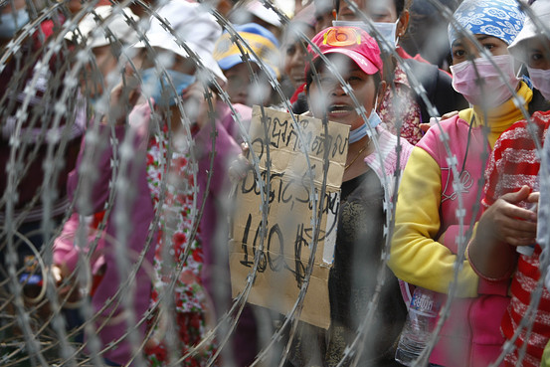

In Cambodia, the women and men who sew clothes for H&M, The Gap, and other major brands struggle to make ends meet. The legal minimum wage for garment workers is a miserable wage of $100 per month. Thousands of workers have fainted at their sewing machines owing to factors including malnutrition, overwork, heat, poor ventilation, and fumes from chemicals used in the manufacturing process. Earlier this year, when over 200,000 Cambodian workers stood up to demand a fairer wage, authorities shot four workers dead in the streets and threw 23 union activists in jail.
Consumers don’t want clothes tainted with exploitation and repression.
On September 17th, garments workers in Cambodia will demonstrate at their workplaces for a raise to $177 per month – the minimum needed to cover basic needs according to a government-appointed task force. Join us to demand justice for Cambodian workers!
For more info: www.union-league.org/cambodia177

