Service Prayers
for the Fourth Sunday of Advent, Year B
December 20, 2020

2 Samuel 7:1-11, 16 • Luke 1:46b-55 • Romans 16:25-27 • Luke 1:26-38

Since Congregations are returning to “in-person” services at different paces, Worship Ways for will be edited for online use. “Rubrics” for virtual services will be noted in red; take and adapt as you need!

Leader should speak the lines of the people, along with the Leader’s lines

Meditation on Community Life: The Advent Wreath
The Advent Wreath, which in recent years has been adopted enthusiastically as a congregational ritual during public worship, actually began as an at-home devotional practice. So if your church is worshipping virtually, encourage your members to create an Advent Wreath in their households.
An Advent wreath has 5 candles arranged in a circle. Candles may be tapers, or pillars:
3 blue or purple, lit on 1st, 2nd and 4th Sundays
1 rose or pink, lit on 3rd Sunday
1 white or gold, placed in the center, to be lit on Christmas Eve.
Surround the candles with evergreen boughs, or other decorative elements that speak to the season of the year. You may want to hold off on the reds and greens of Christmas; Advent is a celebration of anticipation, waiting, getting ready.

Each week of Advent you may invite a household to share their Advent wreath, and take the lead in lighting the appropriate candles.

The Advent Candle Lighting time may be used at the start of worship, or perhaps during the Sermon time, as an interactive devotional time, or a simple Bible study. It may be a moment to help the community reflect on the year past, with its trauma and displacements, in light of the scriptures that call us to faithfully get ready for a new moment in the coming of Christ

Week Four The readings this week tell the beginning of the almost-too-familiar story of Incarnation. 2 Samuel 7 reveals God longing to be among the people. At long last “at rest from their enemies”, King David worries that the Presence of God with Israel dwells in temporary shelter. David wants to honor God with a more permanent tabernacle. But God’s Prophet Nathan challenges him: “Are you the one to build God a house?” Since the time of Exodus, God has been content to “move about” with the people in their midst, in tent and shelter, intimately engaged with them as they make their precarious way in the world. God’s desire is to “plant” the weary people in a place of safety with wise leadership, and access to God’s own Presence.
Although in another generation Israel will build a Temple with a space set apart for the Holy One, in this moment God desires to live life “on the ground” with the people. David’s descendants, however, will have a different kind of house: a dynasty formed from the family of the humble shepherd, called into leadership by God.
The Gospel of Luke tells the story of God again seeking dwelling place amidst the people, in Mary’s womb. Mary, who is part of a poor branch of David’s house, will offer the Holy One shelter and nourishment to grow into the fulness of human life.
One of Mary’s ancient titles in the Church is Theotokos, “God-Bearer”. Her dialogue with the Angel sets the stage for the Holy One to continue the direct and intimate involvement of the Divine with humanity—incarnation as one of us—Divine love and presence becoming flesh of our flesh, bone of our bone. Her song of joy in the Magnificat declares the promise of such Love, to change the world from within to become a place of justice and peace.
Invite someone to read aloud 2 Samuel 7: 1-9a.
Why would God choose to be at work in the world from the inside out?
How does it feel to know God longs to be with us?

Light four candles:

O Holy One, we light this fourth candle,
And marvel at your desire to be one with us.
Let its flame summon hearts grown cold
Into the warmth of a people living in
The Light of Love.
Fill our lives with Love,
making room there for friends and strangers,
all who desire to know you, God with us,
As we work for justice and peace in the service of Hope.

People: Out loud, but muted
God be with us in this Light of Love.
Call to Worship
Sing out, my soul!
Sing of the holiness of God:
People: Out loud, but muted
Who has delighted in humanity;
lifted up the poor, satisfied the hungry,
given voice to the silent,
and grounded the oppressor.

God has blessed the full-bellied with emptiness,
And given the gift of tears
To those who have never wept;
People: Out loud, but muted
God has desired the darkness of the womb,
and inhabited our flesh--

Sing of the longing of God:
People: Out loud, but muted
Sing out, my soul!
©1992 Janet Morley, All Desires Known, adapted
Reproduced with permission

Invocation
O Wondrous God,
send your Messenger to us today with a word of grace
if we are fearful, move us to Confidence.
If we are weary, offer us Rest.
If we are empty, fill us with Hope.
We have been searching for you far away;
Let us find you at home in our midst,
Changing hearts and minds
Urging us to join your work of Love.
We pray in the name of the One who is coming,
Jesus, the Christ.
Amen.

Prayer of Confession
Do not be afraid, said Gabriel,
surprising Mary
and confronting her with the decision of her life.
Do not be afraid, God is with you.
2020 has confronted many of us
with life-changing circumstances and decisions.
We know fear from the inside out.

In this moment, ponder that fear. Name it, if you can, at least to yourself.
Silence
Continue to ponder, and if you can,
try to name where you may hear God calling:
Do not be afraid.

Silence; if it seems appropriate, the leader may invite people to share their experiences.

Assurance of Grace
Our God, who has been with the people since the beginning,
is with us now
offering grace that is more than we can ask or imagine.
God’s love frees us from the past,
and helps us move forward into a new future.
Let us thank God-with-Us, Emmanuel, for faithful love.

Scripture, Sermon, Prayers of the People

Notes for the worship planners in 2020:
Consider a simple message or even an interactive Bible Study that engages people with the Scriptures for today. For the Prayers of the People, you might use a bidding prayer (“God, we pray today for those who are sick, including ….”) and encourage folk to type in their prayers using Zoom chat or Facebook Live; allow for more time in silence for those prayers to be typed and read. Consider a collective response at the end of each bidding prayer.
- A caution regarding prayers of the People online: Folks gathered in-person often recount a lot of detail in their prayers concerning other members or family (“Elderly Name, living alone, experiencing isolation…” In a private, in-person gathering, this information may be safe, but online, it can expose vulnerable people to harm, since we can’t control who will join the gathering or access it later online. Invite people to be prudent in offering prayers: “For First name only, in need of healing”; “For First name only, comfort in grief” etc.
Encourage people to contact the pastor directly with news of those needed extra pastoral care

Call To Offering
In struggle and in joy, God is faithful to us.
We bring forth our offerings – our tithes, our treasures, our least coins –
to demonstrate our faithfulness to God.

Dedication
People: Out loud, but muted
O Faithful One,
accept these gifts of our hearts and hands.
May they be multiplied and magnified
as the living presence of Christ in the world. Amen.

Benediction
Let us go forth
without fear,
creating in our lives a space for
the One who longs to dwell with us,
to share our lives,
and bless our world,
and lead us into the Kin-dom of Justice and Peace.
Amen.

Service Prayers for Advent 4 Year B 2020 are written by the Rev. Susan A. Blain, Minister for Worship and Gospel Arts, Faith INFO Ministry Team, UCC.
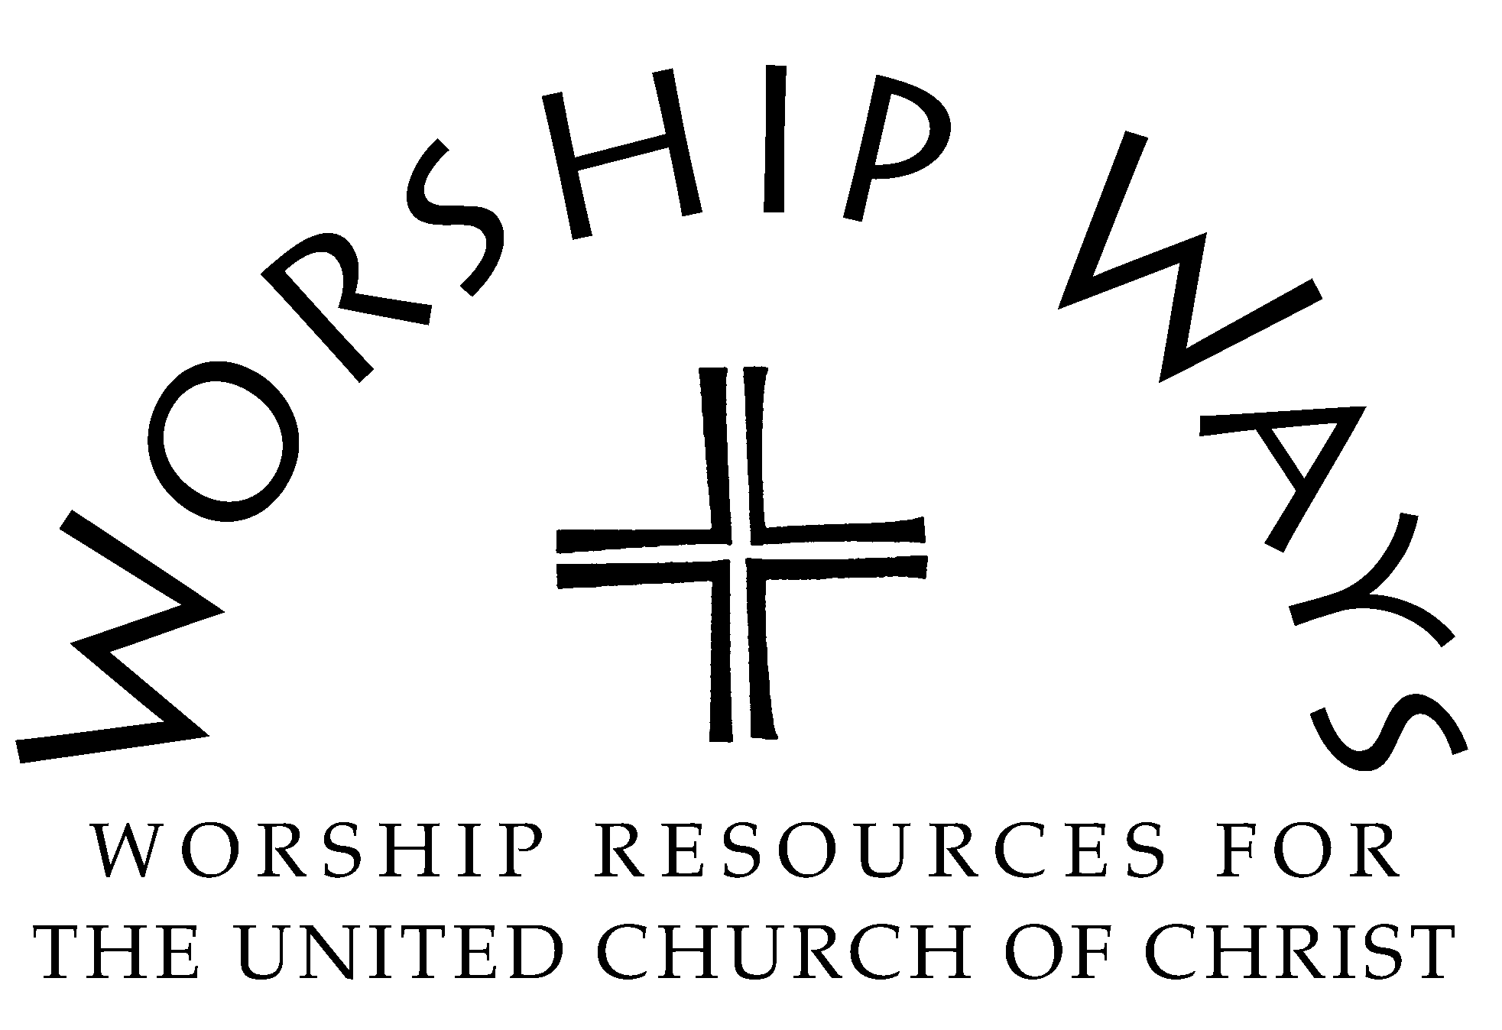

Copyright 2020 Local Church Ministries, Faith INFO Ministry Team, United Church of Christ, 700 Prospect Avenue, Cleveland, OH 44115-1100. Permission granted to reproduce or adapt this material for use in services of worship or church education. All publishing rights reserved.

