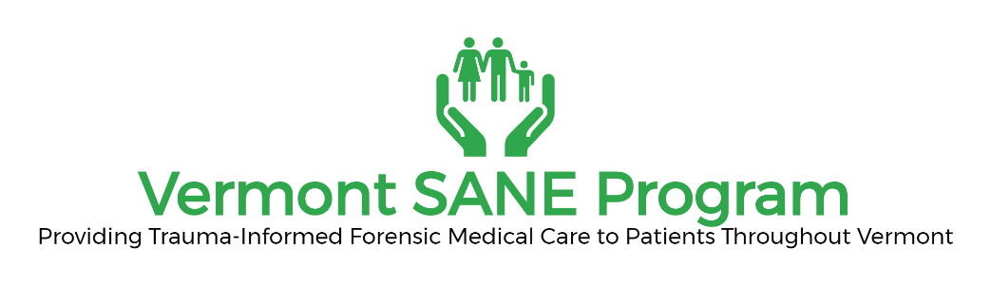

FORM A: Credentialing of Adult/Adolescent SANEs

Name: ______________________________________________________ D.O.B:__/___/____
Last First M.I.

Address: ____________________________________________________________________
Street City State Zip

Phone: _____________________________ Email: __________________________

Check here:

- I am applying to be an adolescent/adult Sexual Assault Nurse Examiner (SANE)

- I have an active Vermont license to practice as a nurse and I have practiced as a registered nurse (RN) or advanced practice registered nurse (APRN) for a minimum of eighteen (18) months and;

- I have successfully completed the educational requirements of the SANE Program.

Attach copies of the following documentation:

- Documentation of successful completion of forty (40) hour didactic education program offered by the Vermont SANE program, IAFN or a training entity approved by the SANE Clinical Coordinator.

- Documentation of successful completion of clinical preceptorship (Form A1).

Attestation

- I hereby attest that the information I have provided is true and accurate to the best of my knowledge.

________________________________
Signature

Please inform the SANE Program of any future changes of address

