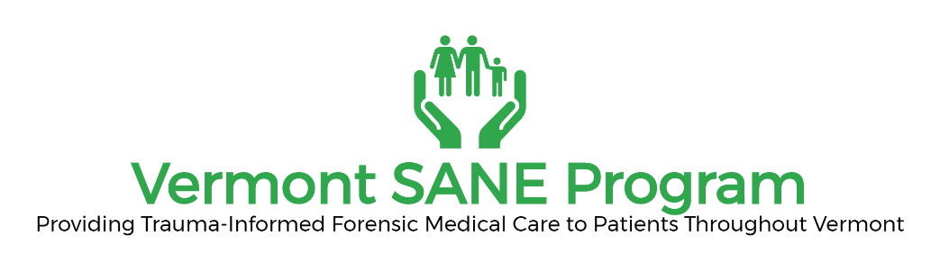

FORM E: SANE Re-Credentialing
Application & Documentation Checklist
Due Date December 15th

Name: ______________________________________________________ D.O.B:__/___/____
Last First M.I.

Address: ____________________________________________________________________
Street City State Zip

Phone: _____________________________ Email: __________________________

Check here to certify:

- I am currently practicing as a SANE in good standing and without any lapse in certification and am applying for re-credentialing as a (check one or both):
  - Pediatric SANE and/or
  - Adult/Adolescent SANE

- I have an active Vermont license to practice as a registered nurse (RN) or advanced practice registered nurse (APRN)

- Over the past two years, I have completed:
  - For Pediatric SANE – two (2) pediatric sexual assault examinations or simulated exams
  - For Adult/Adolescent SANE- four (4) adult/adolescent sexual assault examinations or simulated exams
  - For both Pediatric and Adult/Adolescent SANE four (4) total sexual assault examinations, at least two (2) shall be pediatric sexual assault exams or simulated exams
  - Attended two (2) peer reviews of sexual assault cases- including pediatric review for Pediatric SANE- may be online
  - Self-evaluation and three (3) professional practice goals- minimum of 150 words
  - A minimum of twelve (12) continuing education contact hours during the 2-year credentialing period. Continuing Education shall include education relevant to the primary population you serve and include the following topic areas:
    - Sexual Violence, and nursing best practice
    - Healthcare needs of patients including STIs and long-term health impacts of sexual assault
    - Trauma-informed care
    - Sexual Assault Laws in Vermont Link

Attach copies of the following documentation:

- Documentation of continuing education hours
- Form G: link
- For Pediatric SANE-log of at least 2 pediatric sexual assault exams performed over the 2-year re-credentialing period
- For Adult Adolescent SANE- log of at least 4 adult/adolescent sexual assault exams performed over the 2-year re-credentialing period.
- For both Adult/Adolescent and Pediatric SANE- Log at least four (4 exams 2 of which are pediatric.

Attestation:
I hereby attest that the information I have provided is true and accurate to the best of my knowledge.

__________________________
Signature

Please inform the SANE Program of any future changes of address

