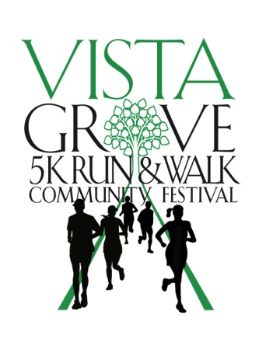
Become a Vista Grove 5K Run & Walk Sponsor
____________________________________________________________
Vista Grove is holding a 5K Bike & Run Community Festival on Saturday, September 21, 2019 at Charles McDaniel Park, 2225 Heritage Drive NE, Atlanta, GA 30045. We hope that you will join us as a Sponsor!

$500 Gold Sponsor - Includes 5 FREE registrations for the bike/run, Logo/Name printed on the T-shirts, banner, and website, time to speak before start of race, a table at event

$250 Silver Sponsor - 2 FREE registrations for bike/run, Logo/Name on banner and website, table at the event

$100 Bronze Sponsor - Logo on banner and website
____________________________________________________________
Vista Grove
www.vistagrove.org
SPONSORSHIP FORM
Check One

______ Gold Sponsor - $500

______ Silver Sponsor - $250

______ Bronze Sponsor - $100

Sponsorship Information

Donor/Sponsor Name as you want it to appear _______________________________

Contact Name __________________________________

Address ______________________________________________________________________

Email ______________________________

Phone ______________________________

Payment Information

____Gold $500 ____ Silver $250 _____ Bronze $100

___ I will mail a check payable to Connect Vista Grove

___ Check enclosed payable to Connect Vista Grove

____Visa ____ MasterCard ____ American Express _____ Discover

Card Number ____________________

Exp _________ Security Code_______ Billing Zip Code

Please return this form and e-mail your logo to Vista Grove Initiative at festival@VistaGrove.org. P.O. Box 98337, Atlanta, GA 30359. VistaGrove is a non-profit 501c(4).
www.vistagrove.org

