Public Safety on Westside Road – November 2019 Update
Accident and Speeding Concerns

In 2017, 2018 and now for a second time in 2019, the Westside Community Association (WCA) petitions Sonoma County officials to address speeding and illegal passing concerns on Westside Road. Exceeding the speed limit and passing on blind bridges, hills and curves is increasing on all segments of Westside.

Request: The WCA requests that County Transportation Department place “Your Speed Is” electronic monitoring equipment in high risk areas along Westside and then increase CHP surveillance and enforcement.

When will the County take action? Public Safety is a primary responsibility of local government. In the past few years alone, there have been four (4) known deaths, including our first bicyclist. In addition, several Westside residents have sported neck braces from literally being driven off their road.

In February 2017, the Westside Community Association requested that the County and CHP/ Sheriff’s office address the increase in accidents and speeding. In 2018, Supervisor Gore asked that WCA provide some evidence of recent accidents. This is our forth request – we now have two studies that substantiate our concerns: 1) Governors Highway Safety report; and the incomplete “Dry Creek and Westside Capacity Threshold Study” released November 6, 2019.

Governors Highway Safety report: This statewide report clearly shows that speeding kills – especially on rural roads with horizontal and vertical curves. WCA shared this report with the County in mid-2019. Download the full report or read the Key Points Summary https://www.ghsa.org/resources/Speeding19

County Traffic Studies released November 6, 2019: (See WCA November 20, 2019 Letter.) The WCA Board supports the recommendation that the County conduct physical traffic counts on Westside during a peak and off-peak weekend to calculate baselines. And, we request the County/consultant create scenarios of currently known developments and potential Use Permit modifications, to generate a cumulative impact analysis before approving additional Use Permits.

Accident Update: There have been four (4) known accidents since WCA’s 2018 letter. A 2018 accident in the 3000 block, the 5th accident at the blind curve near 4603 Westside, a July 2019 pick-up truck launched off the road due to excessive speed, and sadly, a hit and run driver killed a bicyclist on the Dry Creek Bridge. Additional single vehicle accidents may have occurred and not been reported.

The WCA Board also notes that many single vehicle accidents go on-reported as drivers leave the scene of the accident. Board members have observed hit and run incidents involving a power pole at Westside Farms and a truck roll-over in the 3000 block of Westside.

2000 Block: Post July 2019: This pick-up truck literally flew off the road, barely missing a power pole (thankfully), before high centering on a 4-foot cement wall above a creek. This is the 3rd truck driven off the road since 2017.
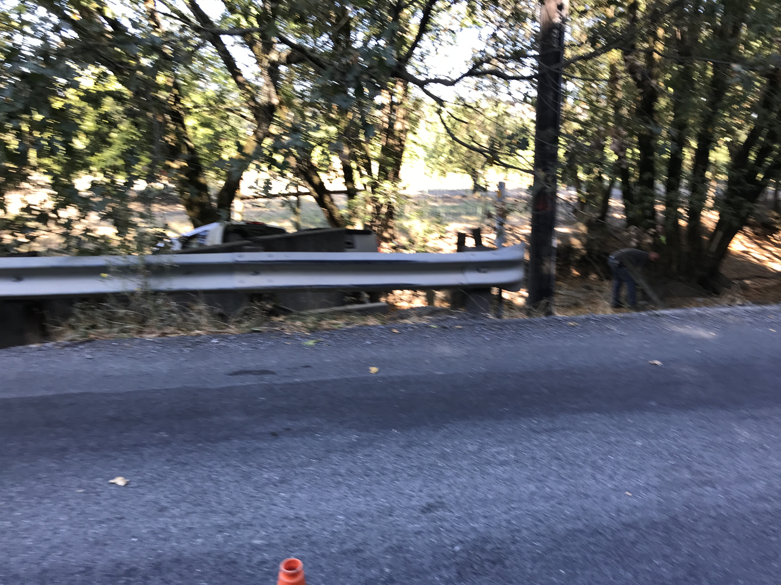
4000 Block: With over 11 reported accidents since 1994, the curve near 4603 Westside is one of Westside’s most dangerous curves. Using data up to 2015, Staff reported a total of 7 accidents (1 fatality, 2 head-on); and in the past two years, there have been four more speeding-related accidents. WCA is not advocating for engineering solutions that destroy rural character; especially because sight lines cannot be improved given creek-related road geometry, and the presence of a hillside.
Three (3) of the accidents occurred after the 2017 BZA decision to deny the 4603 Westside Use Permit. The most recent - 5th accident at this curve was a speeding vehicle heading northbound. The WCA Board thanks the Planning Commissioners for denying an event center at this curve, which is a public safety hazard.
Guardrail damage pictures tell the story of speeding, loss of control and road safety dangers from southbound and northbound speeding-related accidents. Damage from the most recent accident on July 11, 2018 was from a northbound driver speeding in the straight section by MacRostie Winery who lost control at the curve.
Accidents at this curve include a black and red truck, each crossing into the on-coming lane before hitting guard rail and hanging over a creek, as well as guardrail accidents heading north and southbound.
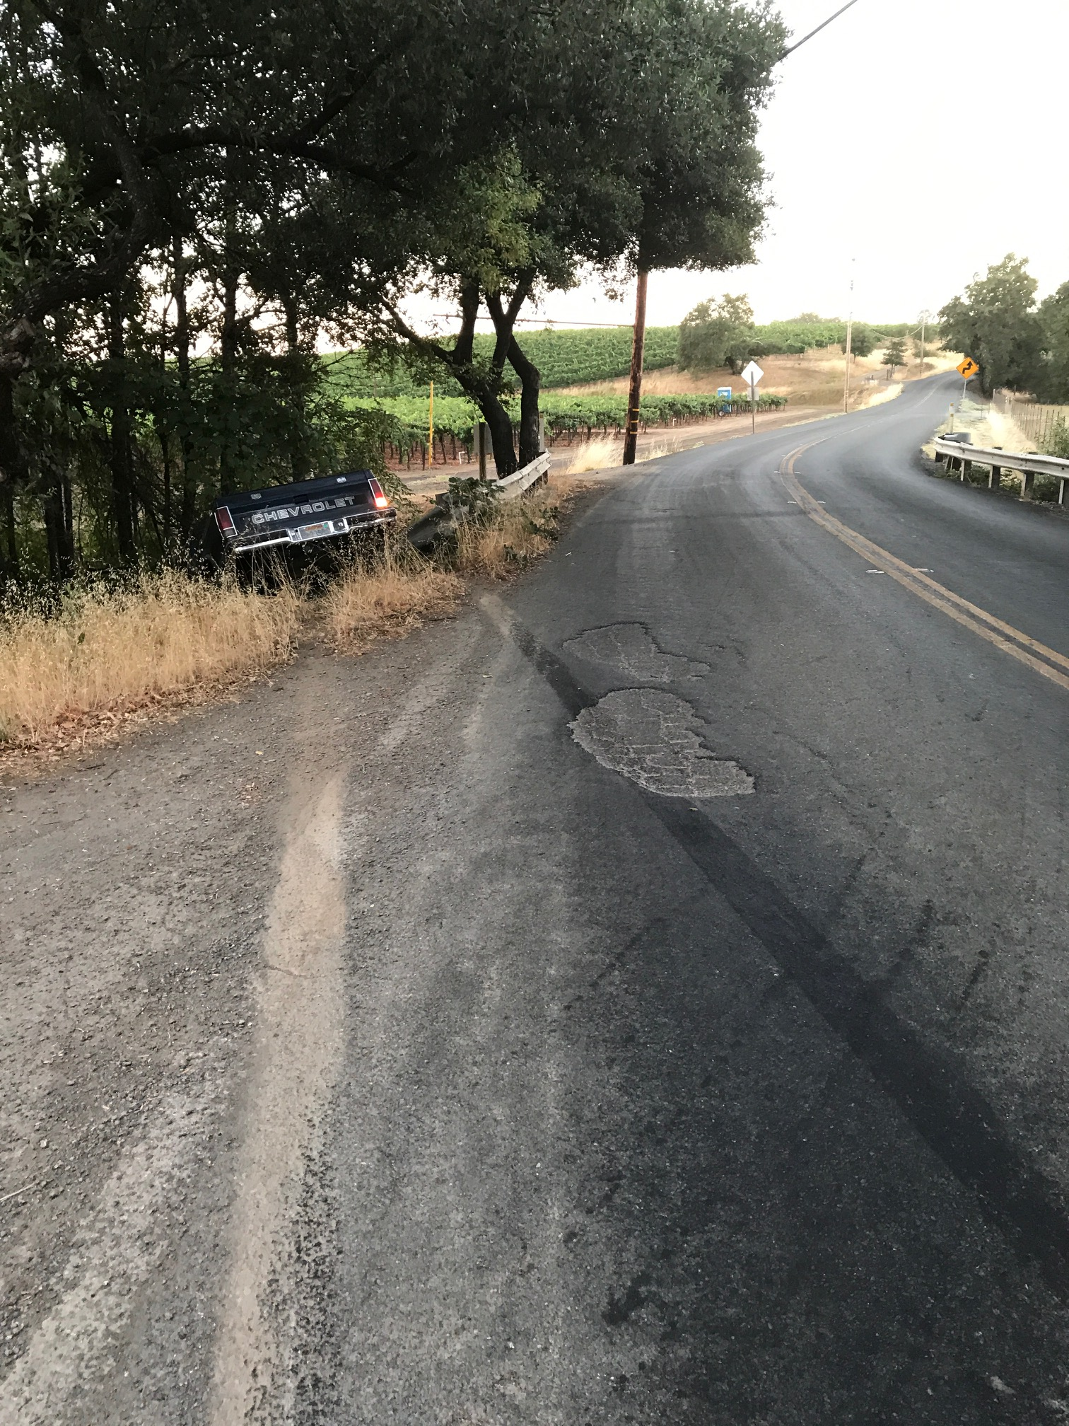
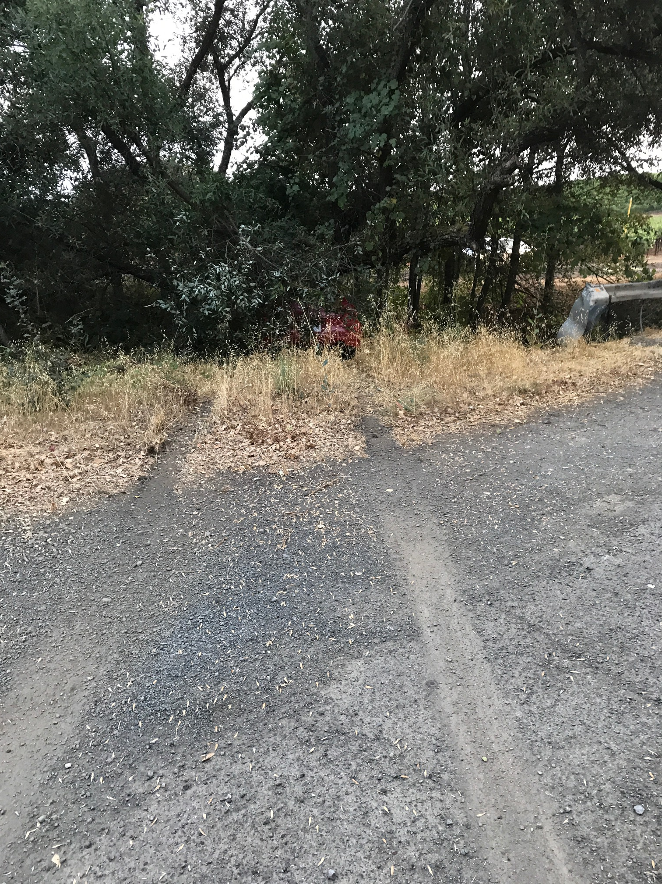

As shown below, distractions from and illegal passing of bicycles lead to additional public safety hazards. These pictures were taken on a Tuesday afternoon in October, 2019. The driver turned left out of the McRostie winery, and practically broadsided a group of bicycle tourists. The driver then crossed the double yellow line around TWO blind curves, barely missing the on-coming vehicle.

See picture at end of Chronology – passing bicyclists on blind curves is a common occurrence. If there had been a head-on, the driver may have walked away, yet how many cyclists could have been killed?

