Part 2: Westside Accident Data: Chronological Accident Information: Increased accident rates and speeding are issues of public safety risks that County officials must take into consideration.
In July – August 2019, a hit and run on the Dry Creek bridge killed a bicyclist. And a speeding truck lost control, flew off the road and high centered on a four-foot cement wall above a creek (2000 block of Westside).
Passing bicycles on blind curves is a common occurance.

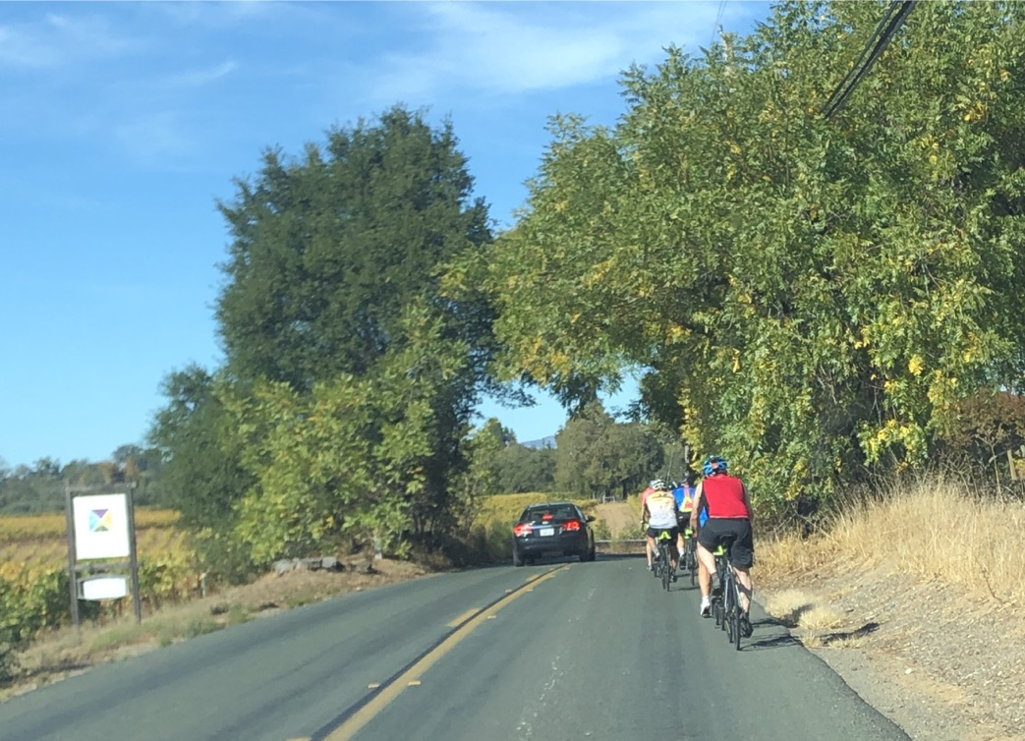
In July 2019, Westside Road got its first “ghost bike” – a bicyclist’s death
due to a hit and run accident on the Dry Creek Bridge.
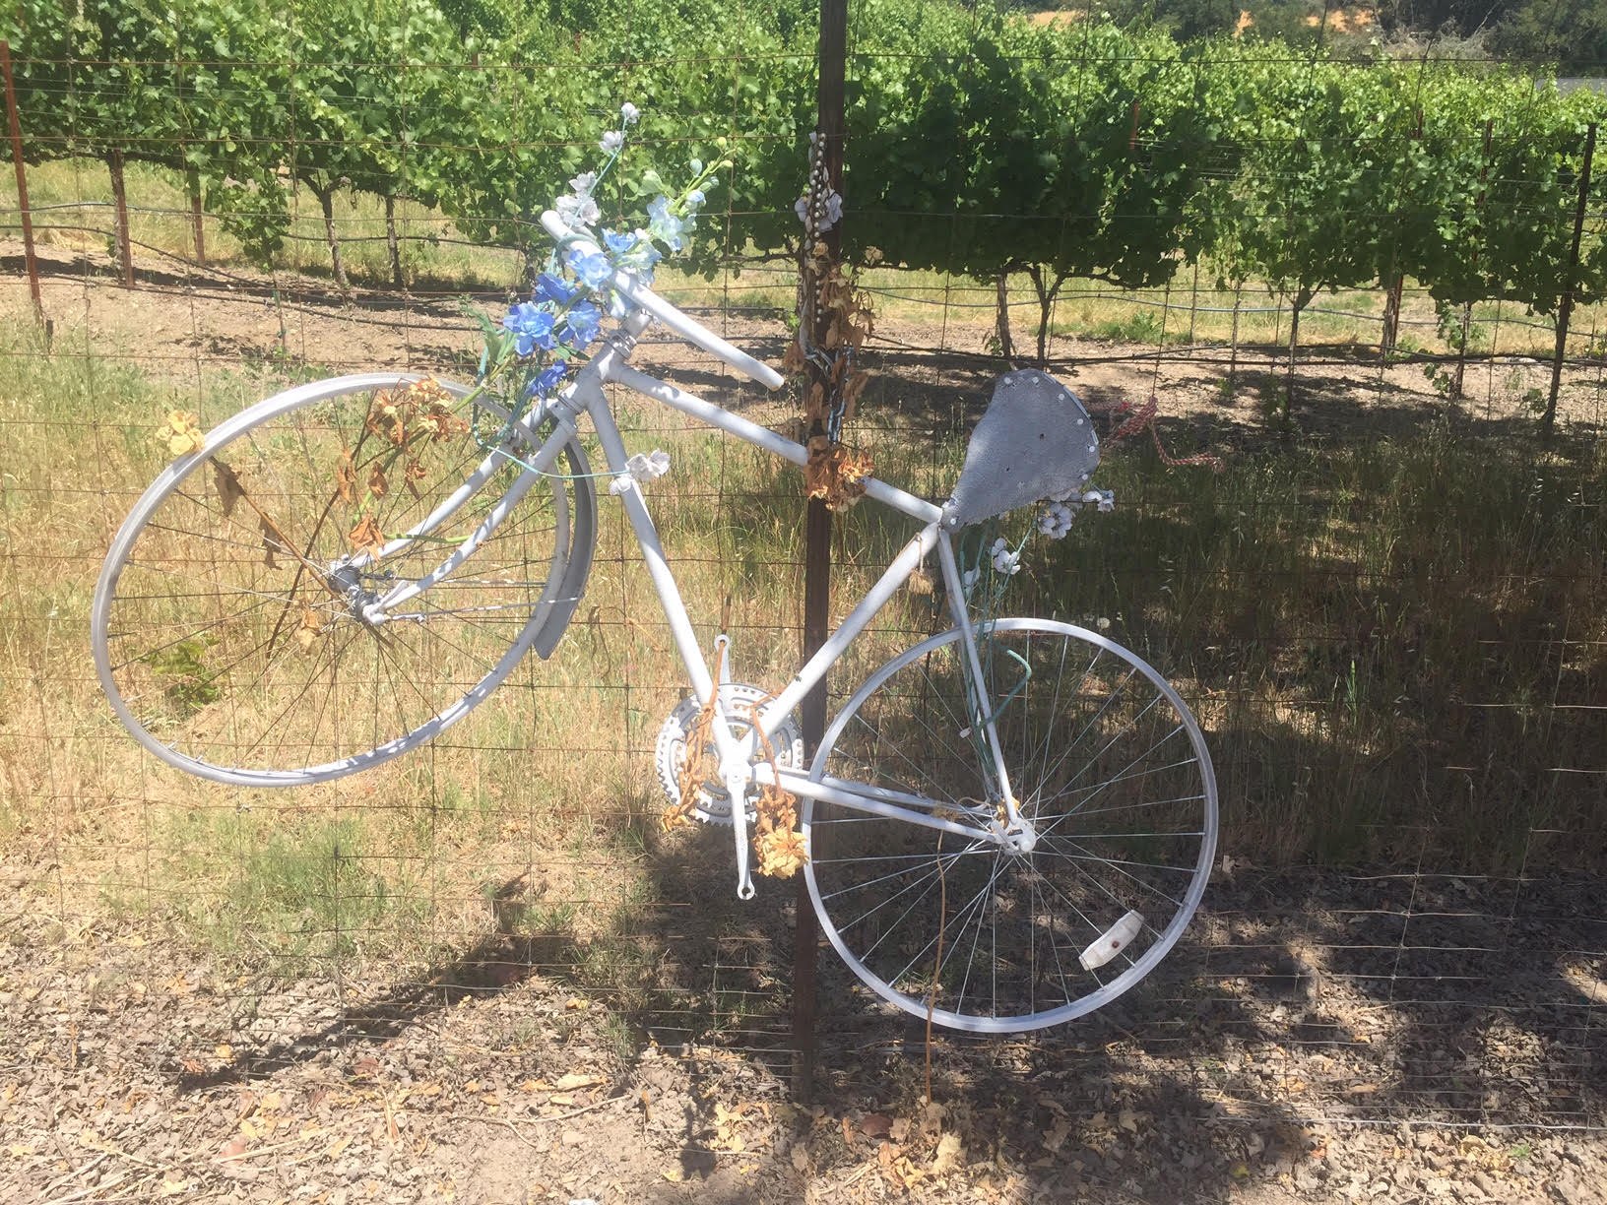

July 19, 2018 - Speeding driver exited Matrix Winery and hit/ totaled a young neighbor’s car; the pick-up driver left the scene of the accident. (CHP report filed). The 2018 accident is the second time a farm worker. our most vulnerable residents, had their vehicle hit and damaged while traveling on Westside. The 2017 accident at the Mill Street intersection, was caused by a driver deemed under-the-influence. A CHP report was filed.

July 14, 2018 a car hit the power pole in front of Thomas George winery, knocking out power and phone service, and starting a fire that required helicopters to extinguish. This is the 4th known power pole accident in the past year or so; others include a car causing a downed power line in front of Westside Farms; the driver left the scene. And two power pole accidents in front of Mill Creek Winery.
In 2017 two separate trucks ran off the road and were hung up over the creek near 4603 Westside curve: See pictures of accidents and Guardrail Damage in Westside’s 4000 block approaching the curve north of 4603 Westside.
On July 11, 2018, there was the 4th accident at the blind curve just before 4603 Westside Road, counting the motorcyclist death several years ago.
In late summer, 2017, there were two single car accidents in this section of Westside Road. Pictures taken by a local resident show the tire tracks across the opposing lane, and the potential head-on risk created by accidents in this location: The 2017 accidents occurred on August 28, 2017 at 8 PM and on September 3, 2017 red truck had a similar off-road accident. Guardrail damage – Left picture: southbound with drop to creek. Right Picture: northbound damage from 5th Accident at dangerous curve near 4603 Westside. Note the guardrail remained compromised for nearly a year, and was replaced after July 2018.
