Cannabis and Hemp Water Usage and Waste Discharge Issues – Author: Laura Waldbaum, Environmentalist, Water Expert and Glass Fire Survivor Dated 2019
Summary
Restrictions on water use and discharges of waste water are intended to protect water resources for all users, including maintaining environmental quality.
Various State agencies have policies and regulations which must be met by commercial cannabis operations. In addition, the operation must comply with Sonoma County’s agricultural regulations and best management practices (VESCO) and the County’s specific Cannabis ordinance requirements.
The State Water Board has developed a new program to allow for users with water rights to temporarily store water. Some forbearance periods are in place for surface water users and may be applied in certain circumstances to groundwater withdrawals. Water use must be self-reported yearly to both the State and the County – a system rife with possibilities of abuse.
The County is allowing for commercial cannabis growing of up to 1.25 acres in water scarce areas as long as the operator has a consultant report which shows no impacts to offsite properties or the environment. The types of reports being submitted to and accepted by the County fall far short of providing this proof.
Possible solutions to better protect the public and the environment are, making designated” Water Scarce” areas unavailable for commercial use. If the County decides that these areas are to be open for commercial development there should be no direct diversions of water and no groundwater pumping.
Finally, requiring real time monitoring of water use by a governmental agency is the only way to insure compliance with water use requirements.
Impacts
The topic of the impacts of cannabis on water supply and wastewater discharge is complicated.
California’s dual licensing system allows for input from both the State and the County and both sets of regulations have extensive language concerning water use and waste discharge. Whenever you have multiple agencies overlapping there is usually a frustrating game of pass the buck.
- The complications are compounded in the case of water as use of water is regulated by California Public Resources Code and Implemented by the State Water Resources Control Board (SWRCB).
- California Department of Fish and Wildlife (CDFW) also has a hand in water issues when they implement policies to protect fish and wildlife.
- In addition, the federal government agency, National Marine Fisheries is tasked with protecting federally listed species and can sue agencies who do not adequately protect these species.
- In the case of waste discharge, it is fairly clear that MAUCRSA has tasked the SWRCB with policing this issue.
- The North Coast Regional Water Quality Control Board put in place a program for waste discharges in the region associated with cannabis (R1-2015-0023) which was in place until October 17, 2017 when the SWRCB took over with its “General Order”. Thus, R1-2015-0023 sunset on July 1, 2019. Now, all waste discharges will be regulated by the General Order.
State Cannabis Water Use Regulations
The subject of water use is more complex. Again, MAUCRSA has outlined specific requirements but has delegated responsibility for identifying compliance with those requirements to CDFW, SWRCB and local agencies. MAUCRSA states that CDFA is the lead agency for license compliance with CEQA and in fact MAUCRSA lays out detailed requirements for compliance where it involves water use.
Medical and Adult Use Cannabis Regulation and Safety Act (MAUCRSA)
Chapter 6 section 26060.1 (a) discusses permitted water sources. They are listed as: a retail water source, a diversion, a groundwater extraction. Each has specific reporting requirements but direct diversion has the most detailed set of needs. Diversion requirements are divided into those applications submitted before Jan 1, 2019 and those submitted after December 31, 2018. These requirements are shortened and paraphrased below:

- Applications submitted before 1/1/2019
- Small irrigation registration or permit
- Statement of diversion filed before 10/31/2017
- Pending application for a permit to appropriate water submitted before 10/31/2019
- Documentation that the diversion is subject to subdivision….
- Documentation submitted before 10/31/2017 demonstrating a riparian water right
- Applications submitted after 12/31/2019
- Small irrigation registration certificate or permit
- A statement of diversion and use filed with SWRCB that covers the diversion and specifies the amount of water used for cannabis cultivation
- Documentation that the diversion is subject to subdivision….
- SWRCB document demonstrates no diversion occurred after January 1, 2010 and in the calendar year when the application was submitted and contains information from Water Code 5103 (name, place of diversion, name of stream, capacity of reservoir months, water used)
Section 26060.1 (b) states CDFA shall include conditions requested by CDFW and SWRCB to (also paraphrased):

- A Insure water use and discharges do not affect flows needed for fish
B Do not negatively impact springs, riparian habitat, wetlands or aquatic habitat
C Protect fish and wildlife habitat and water quality
- Final environmental document with relevant mitigations to be met
- Compliance with Fish and Game code 1602 (streambed alteration permit not needed) 26060.1 (d) CDFA is not responsible for verifying compliance with conditions requested or imposed by CDFW or SWRCB. These agencies shall notify CDFA of violation and CDFA will take action.
California Department of Fish and Wildlife (CDFW)
All applicants for a state license from CDFA must submit either a Lake and Streambed Alteration agreement (LSA) from CDFW or a waiver that one is not needed. This constitutes compliance with Fish and Game Code 1602. An LSA is needed if the project will substantially divert or obstruct a river, lake or stream, if the project will change the stream channel, or if the project will deposit debris where it may pass into a river, lake or stream. This includes all streams, year round and ephemeral streams. CDFW offers three ways to accomplish this.
- Self-Register - If the project is indoors, the applicant can “self-register” using an online tool.
- General Agreement - If the project is in an area with only non-finfish lakes or streams the applicant uses an on-line tool to register. CDFW will then determine if a LSA is needed or a waiver can be issued. This is a ministerial process and relies on the biotic assessment submitted by the project consultant. The general agreement is good for 5 years and has the following requirements regarding direct diversions:
- Maximum diversion to storage 5 acre ft/year
- Seasonal diversion only Dec 15 - March 31
- 50% bypass flow
- Standard Agreement – This process is subject to CEQA and is the choice for projects that do influence finfish watercourses.
California State Water Resources Control Board
The SWRCB has created its own Principles and Guidelines for cannabis cultivation which it calls “Cannabis Policy” It’s a 116-page document adopted October 17, 2017 (with updates mostly relating to tribal land setbacks proposed in February of this year and scheduled to be implemented April 2, 2019).
The document covers two main topics. Water use and waste discharge. The authority for the policy document is Water Code section 13149 which directs SWRCB to develop policies which protect springs, wetlands, and aquatic habitat from negative impacts of cannabis cultivation and may include requirements that require groundwater diversions where the State Water Board determines those requirements are reasonably necessary.
This is to be accomplished through the following programs
- Cannabis Waste Discharge General Order
- Cannabis Small Irrigation Use Certification (SUIR)
- Water Rights Permitting and Licensing
Water use
As stated previously the SWRCB regulates surface water diversions and now to some extent groundwater withdrawals. Direct diversions used for cannabis (taking water from a stream channel) require a water right called a riparian water right. Although these rights run with the land, the SWRCB requires that a statement of diversion be filed yearly documenting water use.
“The main purpose of the Statement Program is to create a central repository for records of diversions and uses of water. This repository differs from the records of appropriated water rights that are registered, permitted and licensed. A Statement is not a confirmed water right; it is simply a statement made by the person or organization who diverted and used the water. Divisions of Water Rights staff do not analyze the contents of a Statement, or research the legal water right status of the diverter at the time of receipt.”
The diversion must meet all the requirements set by CDFW in addition to the following Narrative Instream Flow requirements:
- At least 50% of the water must bypass the diversion;
- The water can only be diverted April 1 to October 31. If the diversion starts before December 15, it can only begin after 7 days of flow above the numeric flow for the watercourse;
- A measuring device must be in place at the point of diversion and all water diverted for cannabis use must be measured daily; and
- Diversion must be at a rate no more than 10 gallons/minute.
In addition, the diversion must comply with the Numeric Instream Flow Requirements. Watersheds have compliance gauges which are recording streamflow. Diverters must check a web based tool each day to determine if minimum flows are being met and if so how much water can be diverted that day. If a specific watershed does not have a gauge, the SWRCB uses a gauge in a similar watershed to predict instream flow numbers.
This all sounds very good and scientific but real world application can be problematic. For example, since all of the data is self-reported and submitted yearly it would be easy to circumvent reporting requirements by tampering with or turning off gauges, or by claiming higher water use needs for domestic or other uses. The operator could divert on days where instream flows do not allow it. Finally watercourse models could be incorrectly applied. For example flow may be greater or lesser in different areas of the creek depending on which tributaries are contributing and where other withdrawals are taking place. So a compliance gauge in one part of the creek may not accurately record what is taking place just up or downstream of the gauge.
Typically diversions from a riparian right are not allowed to be stored. Since diversions can only be made in the dry season, this means that cannabis operators must store diverted water somewhere for use in the dry season. Normally creating off stream storage would involve a lengthy and expensive project to build a dam or reservoir and the creation of an “Appropriative Water Right”. Many water courses are considered fully appropriated and thus no new appropriative water rights can be granted. However SWRCB has created a “streamline process” SIUR to allow for storage of diverted stream water for cannabis cultivation. The SIUR permit allows:
- Diversion of water from November 1 - March 31
- Forbearance April 1 – October 31 Or longer depending on flow
- Maximum diversion rate 10 gpm
- Maximum stored 6.6 acre ft (2,150,619 gallons)
SUIR permits are not allowed:
- On fully appropriated streams
- On Wild and Scenic designated streams
- On CDFW Instream Flow Study areas
To obtain a SIUR permit the operator would have to submit a site specific analysis to show that water is available for their use and pay a fee of $750.00. It is unclear what kind of scrutiny the SWRCB will be giving these consultant reports as part of the “streamline process”, but based on the price tag I would suspect not much. The consultant reports prepared for the County are the same ones submitted to SWRCB. This permit, unlike that for an appropriative right is not subject to CEQA thus avoids time consuming and costly environmental review fees (tens of thousands of dollars).
Fully contained springs which do not run off the property at any time of year, or have surface or subsurface hydrologic connectivity at any time of year, or in any year type are exempt from numeric and narrative flow requirements but are subject to 50% visual bypass and groundwater requirements.
Groundwater uses (wells) which have the potential to significantly affect surface water supply (streams), may be subject to forbearance periods or other measures imposed by SWRCB. This would likely be imposed in areas with water availability issues with multiple applicants or proven connection between surface and ground water.

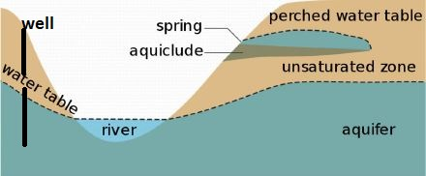
Figure 1
SWRCB has identified Cannabis priority watersheds – they are defined as:
“Watersheds that are at special environmental concern and are at risk of environmental impacts due to cannabis cultivation activities”
The purpose of this designation is to increase voluntary compliance, increase enrolment in water rights program, increase public outreach and protect public trust resources. Two watersheds in Sonoma County are Priority Watersheds; Dry Creek and Mark West Creek.
Waste Discharge
The Waste Discharge General Order was adopted to identify sources of pollutants and regulate those sources to avoid impacts on aquatic life and pollution of waterways. Areas addressed in the general order are erosion control, fertilizer and pesticide management, proper disposal of human waste, runoff control, winterization, water crossings (prevent fish passage barriers, adequate culverts) The requirements are tiered based on threats to water quality. Operators may be exempt from WDR’s or classified as Tier 1 or Tier 2. Those who are exempt may apply for a waiver. WDR waivers are available to:
- Non-commercial growers
- Indoor growers with discharge to on-site sewage facility or community sewer
- Outdoor growers with a maximum 2,000sq/ft disturbed area and slope no greater than 20% with a contiguous cultivation area and compliance with setbacks from watercourses
WDR enrollees at Tier 1 disturb 2,000sq/ft to 1 acre and Tier 2 disturb more than 1 acre. Disturbed land includes land at the site disturbed for all purposes not just for cultivation. Within the two tiers, sites are characterized as low, moderate and high according to slope and setbacks. These are the designations and setback requirements.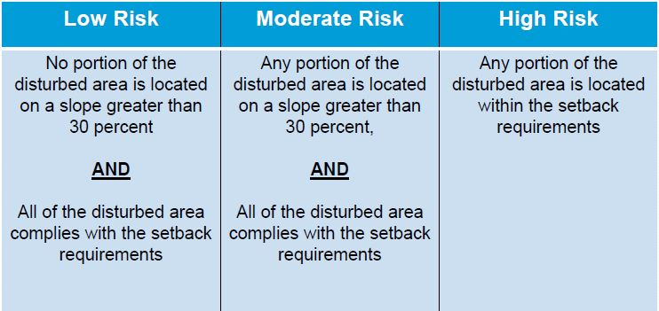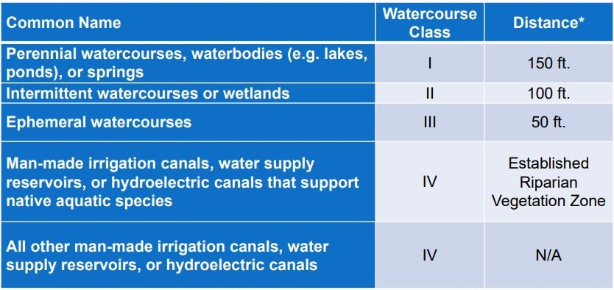
Figure 2
Operators not receiving a waiver and subject to tier 1 or 2 must submit plans to the SWRCB to control sediment and waste as follows:
- Low – Site management plan
- Moderate –Site Management Plan + Erosion Sediment Control Plan”
- High - Site Management Plan + Erosion Sediment Control Plan + Disturbed Area Stabilization Plan (oaks must be replanted 3:1 removed and riparian vegetation replaced 3:1 removed with same size plant)
Fees range from $600.00 to $8,000.00 plus what they have to pay for the plan itself.
CDFA water requirements
All cultivation types must provide evidence of enrollment or waiver of General Order from SWRCB Evidence can include a “Notice of Applicability Letter” Section 8102(p), identification of all water sources used for cultivation 8102(v) LSA permit or waiver from CDFW 8102(w), and evidence that the premises is not located in an impacted watershed as categorized by SWRCB 8102(dd)
In addition section 8107 requires specific information regarding the source of water from any source including details of well drilling reports, data on commercial suppliers of water and compliance with regulations if using a direct diversion. Mapping of water source and storage must also be submitted.
Section 8216 allows for a moratorium on new licenses in SWRCB or CDFW designated impacted watersheds.
Sonoma County Cannabis Ordinance
The Sonoma County ordinance address water use in Section 26-88-254. Subsection (f) “Development Criteria” requires that all runoff and stormwater are subject to Best Management Practices listed in VESCO and that wastewater cannot enter storm rains, waterways or adjacent lands. Subsection (g) “Operating Standards” Item 9 require a wastewater management plan be submitted and verification of WRD enrollment or waiver.
Also from subsection (g) Item 10 addresses water supply. The operator must show that onsite water supply is adequate to meet all needs. Acceptable water sources are:
- Municipal water
- Recycled water
- Surface water with an existing water right and LSA
- Well water subject to the following- if in zone 3 or 4 water areas or medium or high priority basin with a groundwater management plan in place:
- “No net increase in water use through catchment, recycle or reuse system and storage
- Trucked recycled water
- Hydro-geologic report certifying that onsite groundwater is adequate to meet the projected uses and cumulative projected land use in the area on a sustained basis, and the operation will not:
- result in or exacerbate on overdraft condition in the basin or aquifer or
- result in reduction of critical flows in nearby streams or
- result in well interference at offsite wells”
Item 10 of the same section requires groundwater monitoring by checking the static well level, recording it quarterly and reporting it to PRMD on January 1 of each year.
As with the State requirements, the devil is in the details. Here again we are relying on the operator and their consultants to do things properly.
According to the proposals in the Permit Sonoma files, the average price for a hydro-geology study is around $5,000 to $7,000.
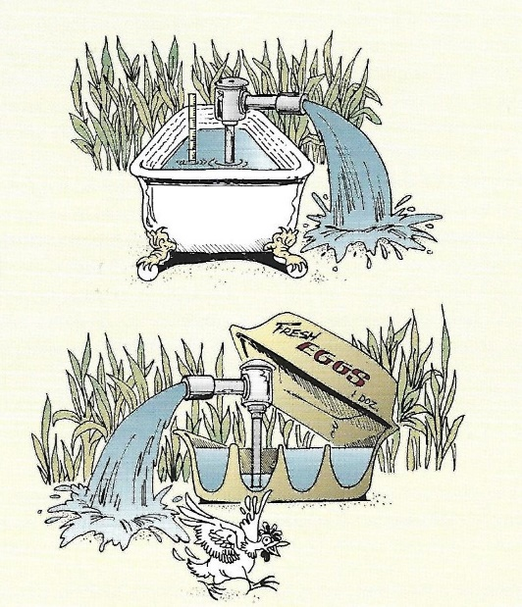
There is simply no way to do an adequate investigation and report for this price. Many reports failed to do any site-specific investigations and rather rely on regional maps and well drillers logs from decades ago as data upon which to base the report. Without an extensive investigation, including on offsite properties, there is simply no way to quantify the extent of the aquifer the well is drawing from. Referring to the diagram (Figure1) above the well could be in the same aquifer as the stream or adjacent wells, or could be in a separate aquifer such as the perched water shown in the diagram. Aquifers may be separated by impervious rocks so withdrawal from one of these separate aquifers would not affect the neighboring aquifers or surface water flows; or can be hydrologically connected as one continuous water source as shown in Figure 2. Without an area wide subsurface investigation, almost nothing is known about the effects of water withdrawals for cannabis projects on neighboring wells and streams. The hydrology reports requested by the County do not even scratch the surface of what must be known before it can be determined that: “…the operation will not:
- result in or exacerbate on overdraft condition in the basin or aquifer or
- result in reduction of critical flows in nearby streams or
- result in well interference at offsite wells”

So, what’s the solution?
One option is to eliminate item (c) hydrology report option in water scarce areas. If a proper report cannot be done by individual property owners due to the regional nature of aquifer investigations, then water scarce areas should be off limits until the County does an area wide thorough investigation of the hydrology of the areas in question. The exact location and extent of the aquifers in particular areas of interest must be determined through subsurface investigation (drilling); whether they are hydrologically connected to surface water and in what season, water balance for existing users including public trust resources, exact requirements for minimum instream flows etc. In the meantime, these class 3 and 4 water scarce areas should be off limits to commercial use of all types.
At the very least we need to insist that the reports use real site data. Real investigations must be done and reports relying on regional data must be rejected. The County should not be accepting reports which have disclaimers. If the consultant cannot state with certainty that they understand what is occurring subsurface, then their work is not done. If consultants are not able to prove that projects will not result in or exacerbate on overdraft condition in the basin or aquifer, or result in reduction of critical flows in nearby streams, or result in well interference at offsite wells then they do not meet the criteria set by the County and the State to protect the environment.
Self - monitoring should be eliminated as a method of checking compliance and pump data and flow measurements should be reported in real time to some agency tasked with verification. Once a year reporting is inadequate.
All groundwater withdrawals for commercial use in class 3 and 4 areas should be subject to the same forbearance period as direct diverters in these areas.
Where there are multiple applications in a single area, the applications must be looked at as a whole not piece by piece as each one comes up for approval. Only by analyzing all of the current applications and any future development possibilities in an area can cumulative impacts be established. Skirting cumulative impact analysis by approving on a piecemeal basis project by project is bad land use planning.

