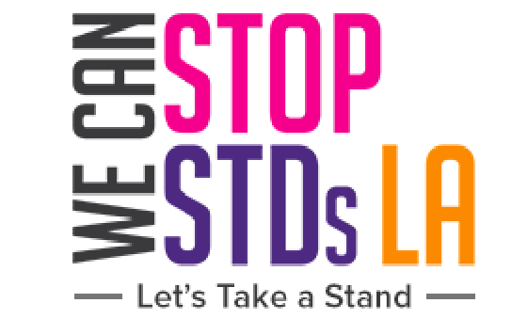

Social Media Kit
November: World Antibiotic Awareness Week (11-17) | International Survivors of Suicide Loss Day (21) | National Family Health History Day (26)

Hashtags: #WorldAntibioticAwarenessWeek #InternationalSurvivorsofSuicideLossDay #National Family Health History Day

ORGANIZATIONS TO LIKE OR FOLLOW:
Organization | Instagram Handle | Twitter Handle | Facebook
KIR-T | @keepingitreal_together | @kir_together
C2PLA | c2pla
REACH LA | @REACHLA
The Positive Results Corporation | @thepositiveresults | @prc123org
Black Women For Wellness | @bwwla | @BW4WLA | @blackwomenforwellness
Get Smart Before You Get Sexy | @getsmartb4ugetsexy | @GSB4UGS | @getsmartb4ugetsexy
Teen Source | @teensourceorg | @teensource
The L.A Trust | @thelatrust
St. John’s Well Child | @wellchildorg | @wellchildorg
St. John’s SLAY | @stjohnsslay | @stjohnsslay
Planned Parenthood Los Angeles | @pplapeeradvocates | @pplosangeles | @plannedparenthoodla
The Wall Las Memorias Project | @the_wall_las_memorias | @thewallmemorias | @thewalllasmemorias
Get Prep LA | @getprepla
LA Condom | @lacondom |  | @lacondom
Amaze.org | @amazeorg |  | @amazeparents
Essentia  l Access Health | @essential_access_health | @essnaccesshlth | @essentialaccesshealth
Int'l Planned Parenthood Fed. | @ippf_global | @ippf | @plannedparenthood
CALCASA – California Coalition Against Sexual Assault | @cal_casa | @calcasa
AMAAD – Arming Minorities Against Addiction & Disease | @amaad_institute | @amaadinstitute

November 6 | LA Women's Taskforce 15th Treatment Summit | 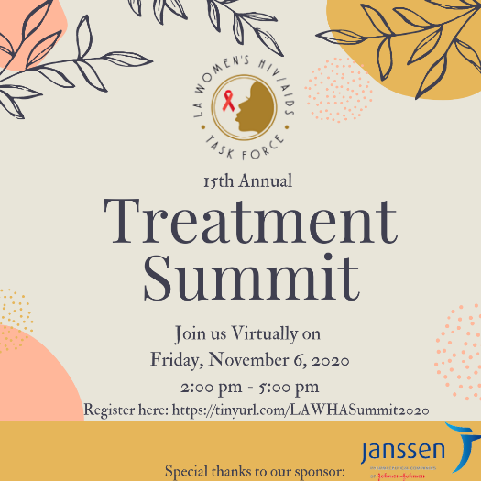  The LA Women's HIV/AIDS Taskforce now celebrates it's 15th year planning and hosting a Treatment Summit in Los Angeles County that focuses on Women living with HIV/AIDS. The summit aims to bring hope, up to date information, and community resources at its Annual Treatment Summit.
November 7 | 2020 South LA Renaissance: Homecoming Edition! | 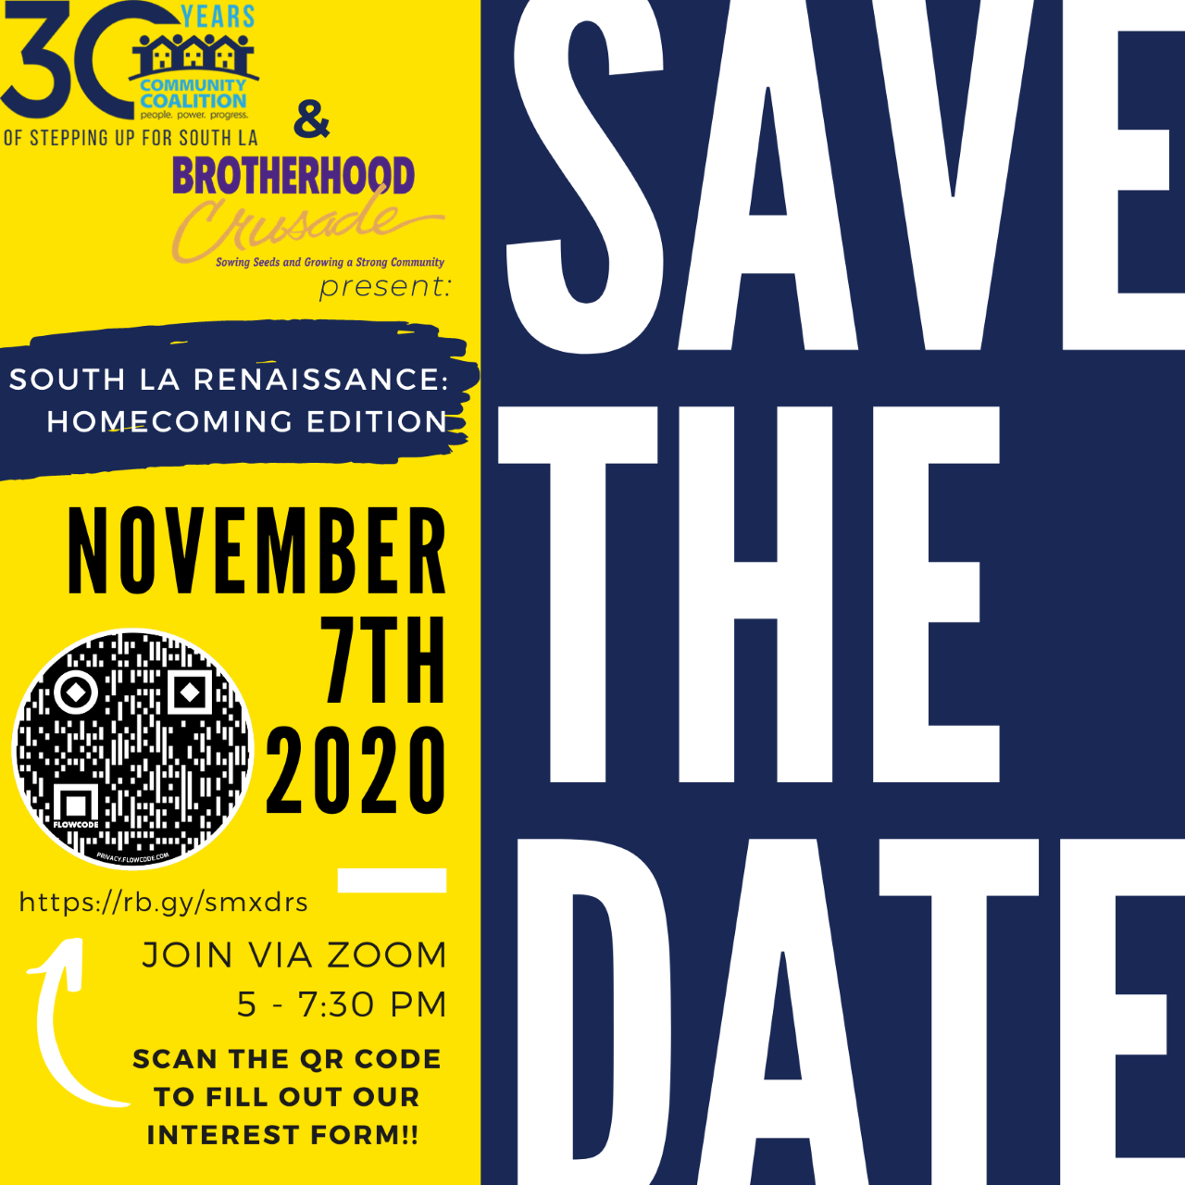  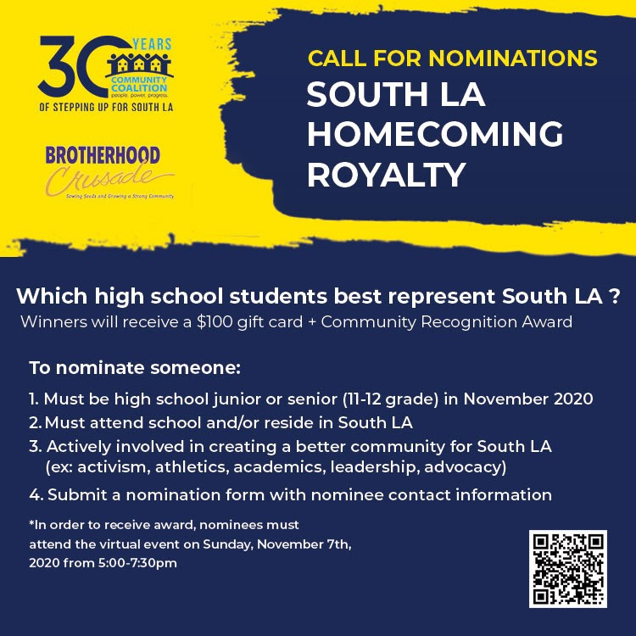We will be bringing South LA youth together to talk about their experiences within our community and to connect them to opportunities to shape policy decisions in LAUSD and in LA county. Policy and advocacy areas include education, substance abuse prevention, wellness services, and other areas the youth identify as high priorities. Students can join our virtual event by filling out our interest form here: https://forms.gle/fzLaEM4niFD1pXcD9
November 11-17 | World Antibiotic Awareness Day | 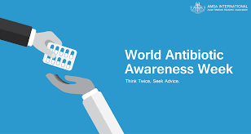  World Antibiotic Awareness Day aims to raise awareness of the seriousness of antimicrobial resistance and to encourage safety with antibiotics.
November 11 | Post Election Forum | 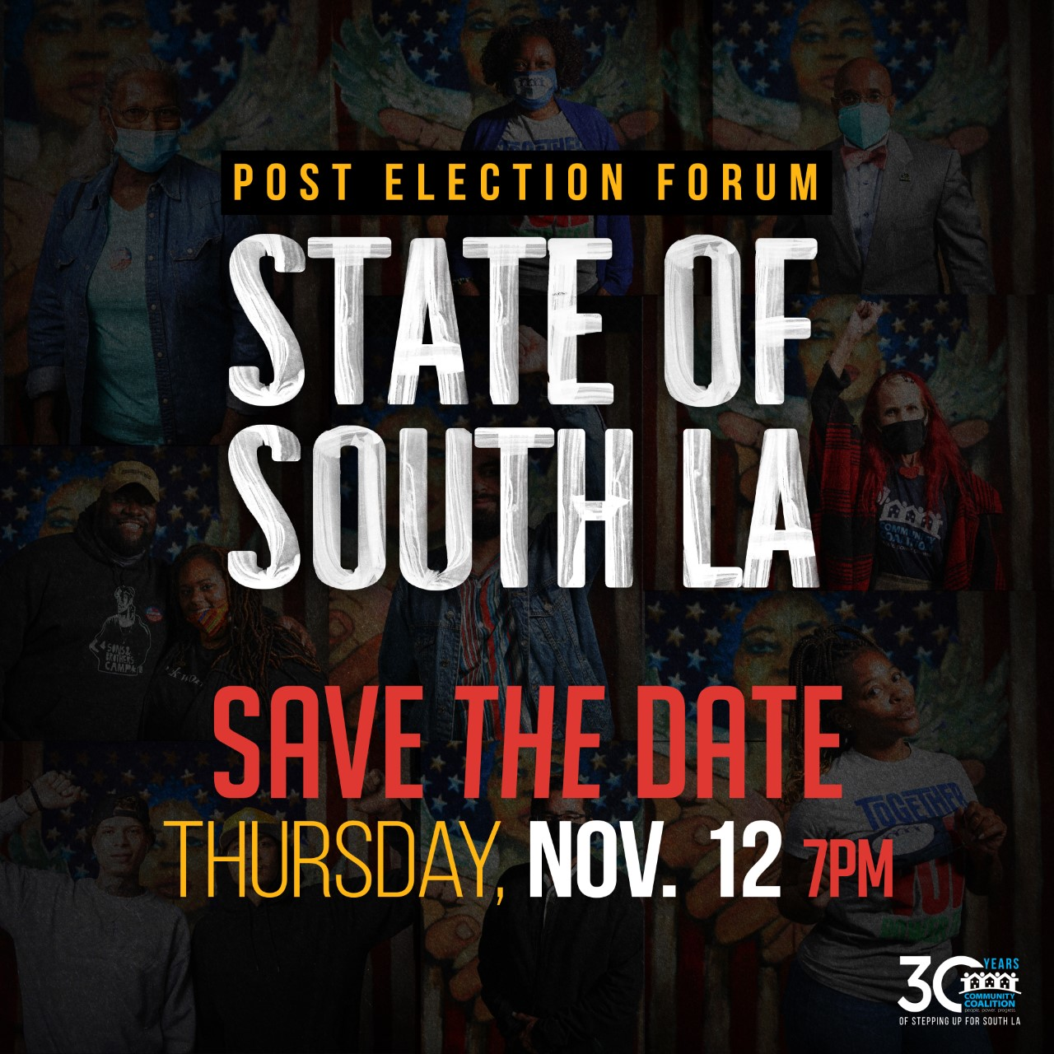  Expanding our democracy and achieving bold, structural reform isn’t about one proposition or one election. It’s about continuing to organize our communities while demonstrating our people power. Los Angeles’ newly elected leaders are stepping into distinct responsibilities and leadership roles at a critical time.  https://action.cocosouthla.org/post_election_forum?utm_campaign=national_day_of_action&utm_medium=email&utm_source=cocosouthla
November 12 | ESA Webinar | Join Essential Access Health for a FREE Webinar on  Teens + Telehealth:  Expanding Access to Sexual + Reproductive Health Care  for California Youth  Thursday, November 12th  2:00 PM - 3:00 PM PST  https://us02web.zoom.us/webinar/register/WN_8CVlWJ1-QJaTTSuzNXWv9g?eType=EmailBlastContent&eId=98bb1fe6-7406-4600-a0aa-7fce99b05d97
November 12 | Youth Community Forum | 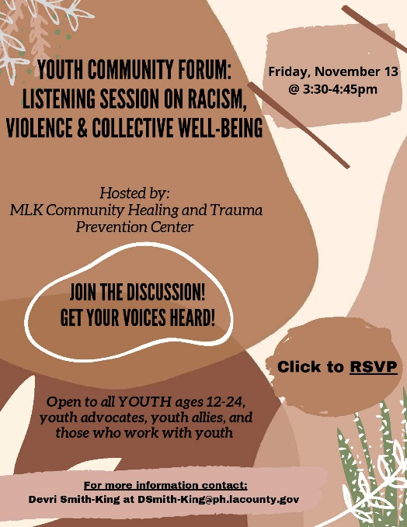  Please join us next Friday, November 13th, from 3:30-4:45pm, as we engage youth aged 12-24 in an open dialogue discussing racism, violence, and collective well-being. This listening session will guide topics for future youth community forums and is open to all youth; and youth advocates, allies, and individuals that work with you. You can register by downloading the attached flyer and clicking on RSVP or on the link below:  https://lacpublichealth.webex.com/lacpublichealth/onstage/g.php?MTID=e8940c961bcfe9b1bfae9cb0e4f49cb6f
November 21 | International Survivors of Suicide Loss Day | 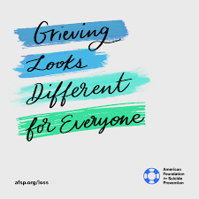  International Survivors of Suicide Loss Day is a day for family and friends of those who have died by suicide to come together and health.
November 26 | National Family Health History Day | 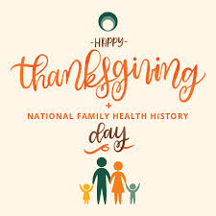  National Family Health History Day is celebrated every Thanksgiving as a way to learn about medical issues that run in your family.

