Applicant Information
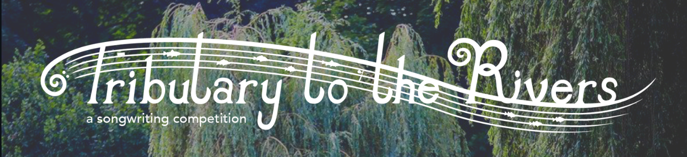
First Name:
Last Name:
Email:
Phone Number:

Submission Information
Song title:
About your song:

How was your song submitted (Please highlight) YouTube Link MP3/4 Video

Please fill your name (if the applicant is under 18, a parent guardian must complete) the following statements:

I _________________________confirm that the song submitted to the Tributary to the River Song Competition is an original song that I own the rights to.

I _________________________have read the rules and understand that by submitting this form I am indicating that I agree with the rules of the Tributary to the Rivers song competition and my submission is in compliance with the rules.

Signature:________________________________________ Date:________________________________

