We, the undersigned customers, want FiOS, which is built, installed and maintained by union workers. We want access to Verizon FiOS service, but it is not currently available to us. According to its agreement with NYC, Verizon has a responsibility to make FiOS available throughout the city. Making FiOS available to all New Yorkers will create good jobs and deliver the best, all fiber-optic service. Please support good jobs and good customer service by ensuring access to FiOS.
Name Street Address City, State & Zip
______________________________________________________________________________________________________________________
______________________________________________________________________________________________________________________
______________________________________________________________________________________________________________________
______________________________________________________________________________________________________________________
______________________________________________________________________________________________________________________
______________________________________________________________________________________________________________________
______________________________________________________________________________________________________________________
______________________________________________________________________________________________________________________
______________________________________________________________________________________________________________________
______________________________________________________________________________________________________________________
______________________________________________________________________________________________________________________
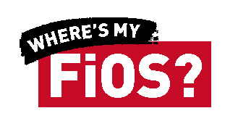
______________________________________________________________________________________________________________________
Fight for Good Jobs and Quality Service at Verizon: Tell your family and friends who want FiOS but can’t get it to go to www.wheresmyfios.com
Please return petition to: CWA District 1, 80 Pine St, 37 Fl, NY NY 10005

