Thursday, October 24th
Time | Event | Where
9:00 AM | PACKING THEN AND NOW - Part 1  Learn about the historical packing practices in the backcountry through an informative slide show and discussion | Demonstration Tent
10:00 AM | PACKING THEN AND NOW - Part 2  Watch demonstrations of preparing different kinds of loads and rigging them on animals to pack into the backcountry | Round Pen  Parking Lot
11:30 AM | UNDERSTANDING ENCOUNTERS BETWEEN HORSES AND OTHER TRAIL USERS – Hikers and Bikes  Wonder what to do when meeting horses on the trail? This session will demonstrate proper encounters between mounted horses, hikers, and bicyclists. | Round Pen  Parking Lot
1:00 PM | LEAVE NO TRACE FOR STOCK  Overview of Leave No Trace as it applies to stock users in the wilderness. | Demonstration Tent
2:00 PM | CARE AND FEEDING OF EQUINES IN THE BACKCOUNTRY  Care of Stock in the Backcountry an overview including feeding and first aid. | Demonstration Tent
3:00 PM | UNDERSTANDING ENCOUNTERS BETWEEN HORSES AND OTHER TRAIL USERS – Motorized Vehicles  How do stock react to ATV’s, motorcycles, and E-bikes? Learn how motorized uses and stock can co-exist by understanding horse behavior and the reasons behind it. | Round Pen  Parking Lot
3:30 PM | DUTCH OVEN COOKING FOR A CROWD  Learn how to plan, prepare, and cook for large crowds in the backcountry. Understand how to meet serving challenges. Free samples. | Camp Cook Tent

Friday, October 25th
Time | Event | Where
9:00 AM | PACKING THEN AND NOW - Part 1  Learn about the historical packing practices in the backcountry through an informative slide show and discussion | Demonstration Tent
10:00 AM | PACKING THEN AND NOW - Part 2  Watch demonstrations of preparing different kinds of loads and rigging them on animals to pack into the backcountry | Round Pen  Parking Lot
11:30 AM | UNDERSTANDING ENCOUNTERS BETWEEN HORSES AND OTHER TRAIL USERS – Hikers, Bikes, and Vehicles  Wonder what to do when meeting horses on the trail? This session will demonstrate proper encounters between mounted horses, hikers, bicyclists, ATV, motorcycles and other vehicles. | Round Pen  Parking Lot
1:00 PM | WILDERNESS TOOLS - ALL ABOUT CROSSCUTS  - The ultimate tool for wilderness trail clearing  - Saw selection; cut like butter, not a Misery Whip  - Demonstrations of proper technique  - Saw Efficiency, Maintenance, Safety, User Tips! | Demonstration Tent
2:00 PM | TRAIL CLEARING - SPECIFIC TRAIL OBSTACLES  - The use of crosscuts on timber Jackpots  - Undercutting, Binds and Tension  - Tools to help – Wedges, Ropes, Cables  - Demonstrations of proper techniques  - Safety | Demonstration Tent
3:00 PM | PACKING SAWS AND TRAIL TOOLS ON HORSES  Watch demonstrations of different pack loads | Round Pen  Parking Lot
3:30 PM | THE BIG RACE – POWER SAW – VS- CROSSCUT  Who will win the battle between human and gas powered saws. | Demonstration Tent

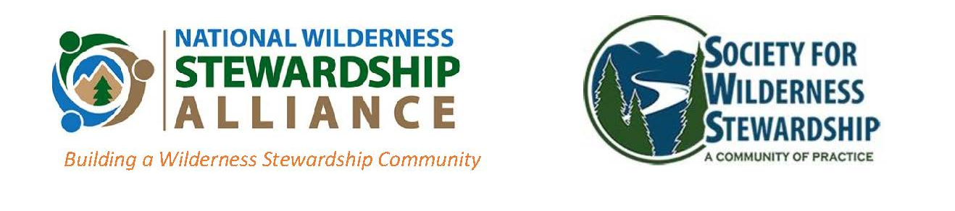

Present the

“Wild Olympics”

Teams of 2-6 compete in 3 events.

    - Cross-cut saw competition for style
    - Manti-tying for equal weight
    - Timed tent pitching while impaired

Thursday - 5:00 – 7:00
Camp Area
Demonstration Tent

