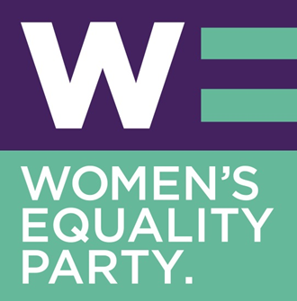

Women in Equality Black Country Branch Meeting

Monday 22nd May 2017

18:00 – 19:30

Arena Theatre, University of Wolverhampton

18:00: Welcome and introductions
WEP Black Country Branch Officer

18:15: Mayoral Contest
Recap of the Mayoral debate and discussions on how we can work with the new Mayor

18:30: National Campaign
Members’ involvement in the national campaign
Members input in the WE BC branch meeting Agenda

19:00: Break
Summative comments and break for refreshments (bring and share)

19:10: WEP News
Register your vote
Growing membership

19:20: Equality Picnic Proposal
Planning

19:30: CLOSE

Next Meeting: Monday 26th June 2017.

