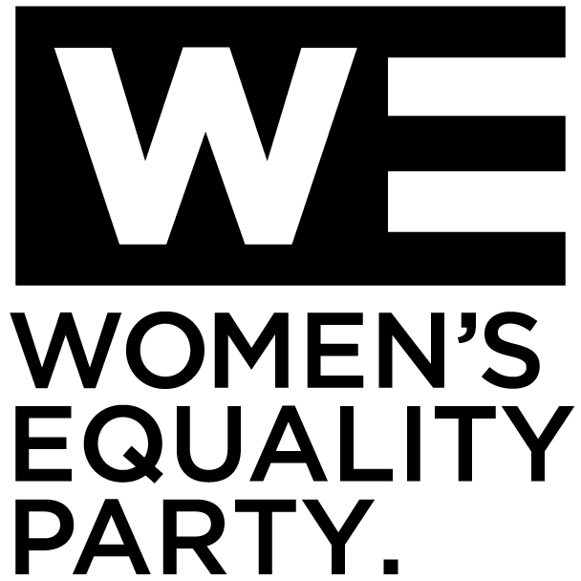

Equal Opportunities Monitoring Form

WE are committed to recruiting, retaining and developing team members which reflects the diverse communities with whom we work and seek to represent. It is vital that we monitor and analyse diversity information so that we can ensure that our HR processes are fair and transparent. Any information provided on this form will be treated as strictly confidential and be used for statistical purposes only. It will not be seen by anybody not directly involved in the recruitment process.
_________________________________________________________

Gender

☐ Prefer not to say

Age ☐16-24 ☐25-29 ☐30-34 ☐35-39 ☐40-44 ☐45-49 ☐50-54 ☐55-59 ☐60-64 ☐65-69 ☐70 and over

What is your ethnicity?
Ethnic origin categories are not about nationality, place of birth or citizenship. They are about the group to which you as an individual perceive you belong. Please indicate your ethnic origin by ticking the appropriate box.

White
☐English ☐Welsh ☐Scottish ☐Northern Irish ☐Irish
☐Gypsy or Irish Traveller ☐Other White background

Mixed/multiple ethnic groups
☐White and Black Caribbean ☐White and Black African
☐White and Asian ☐Any other mixed background

Black /African/Caribbean/Black British
☐African ☐Caribbean
☐Any other Black/African/Caribbean background

Asian/ British Asian
☐ Indian ☐Pakistani ☐Bangladeshi ☐Chinese ☐Any other Asian background

Other ethnic group
☐Arab ☐Any other ethnic group

Prefer not to say ☐

Do you consider yourself to be disabled?
☐Yes ☐No ☐Prefer not to say

What is your sexual orientation?
☐ Heterosexual/straight ☐ Gay woman/lesbian ☐ Gay man
☐ Bisexual ☐ Other ☐ Prefer not to say

What is your religion or belief?

☐No religion ☐Buddhist Christian ☐Hindu ☐ Jewish
☐Muslim ☐Sikh ☐Any other religion ☐Prefer not to say

