- I have peace in my fingers Song:
I have peace, peace, peace in my fingers watch what I can do.
I have peace, peace, peace in my fingers I ‘m going to wave my hands at you!
I have words, words, words in my head, watch what I can do.
I have words, words, words in my head, I’ m going to talk things over with you!
I have love, love, love in my heart, watch what I can do.
I have love, love, love in my heart, I’ m going to give some to you!

- Kindness Daily Five: Trace your hand on a piece of paper and write down five different things that you are going to do be kind. Practice being kind to someone each day.
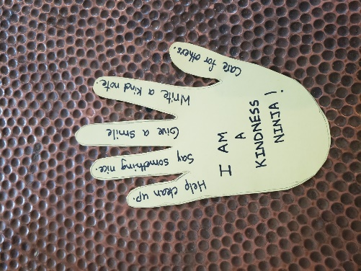
- Kindness Jar: Take a container and label it as Kindness jar. Encourage your child to do kind things every day and each time they do some kind things put a cotton ball in the container. Count the cotton balls at the end of each week and if they have counted 20 or more then celebrate their achievement by declaring them as KINDNESS NINJA of the week. Surprise them with their favorite food item or read their favorite book to them.
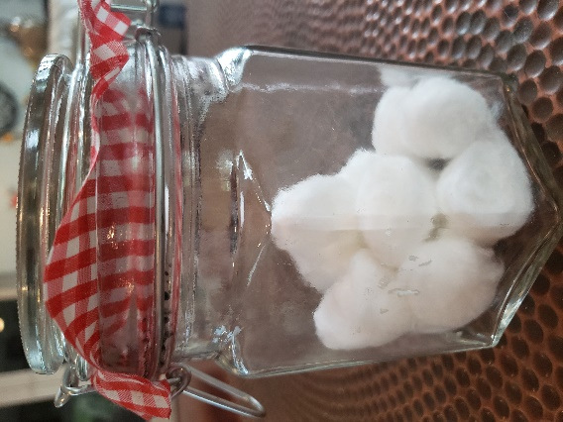
- Kindness Yoga:
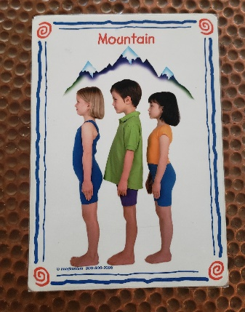
- Mountain Pose- Stand tall with shoulders, hips and feet all aligned. Think of being KIND to yourself. Smile and take deep breaths.
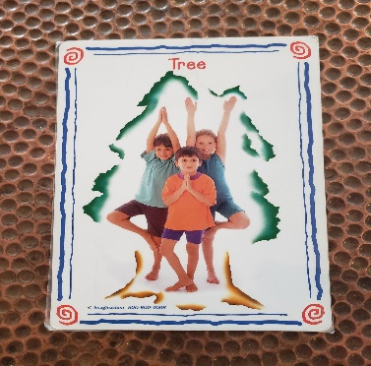
- Tree Pose: Stand tall and balance on one leg Hands can be either up in the air or prayer position. Close your eyes and take some deep breaths and think about being KIND to the environment.
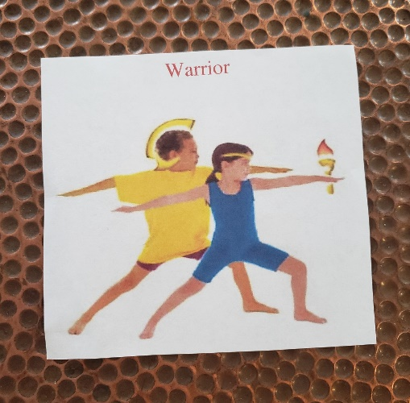
- Warrior Pose: Step one foot back, your arms parallel to the ground, bend your front knee and look forward. Think of being kindness warrior and being kind to others.

- Kindness Chain: Take colored paper and cut them in stripes. Each time your child does something kind ask them to draw a picture and then start making the kindness chain using some glue.
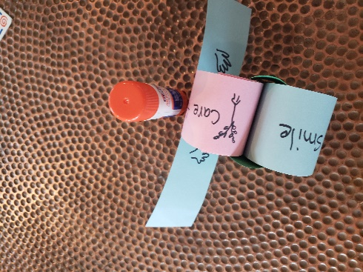
- Act of Kindness: Ask your child to record their KINDNESS actions by drawing a picture of their act.
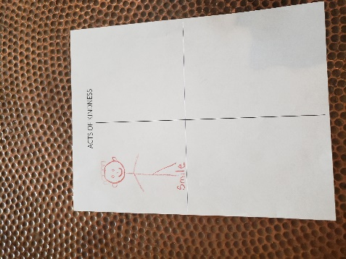
- Fun with marker: You will need water, expo marker, plate, and a straw for this activity. Draw any shape on the plate with the marker and then add some water to see the magic. The shapes will start floating in the water and now use the straw to blow the shapes around and fun.
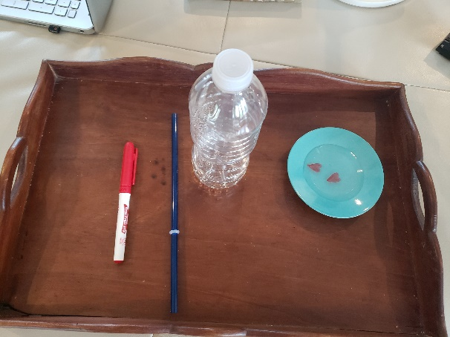
THANK YOU and STAY SAFE AND STAY HEALTHY!

