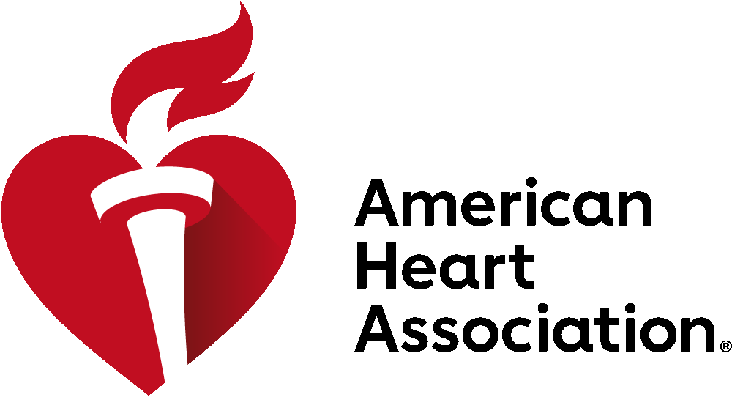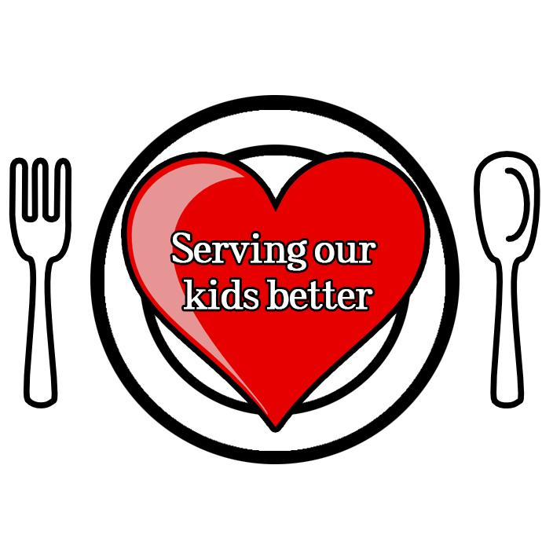

Why support legislation ensuring restaurant kids’ meals are healthy, including default healthy drinks?

- We are asking Vermont legislators to support healthy kids’ meals in restaurants by having healthy drinks be the default choice in kids’ meals and ensuring restaurant kids meals marketed to children meet healthy nutrition standards.

- Vermonters’ lives are busy, and more and more, families are grabbing a meal on the run or eating out. In fact, Americans now spend more of their food budget on foods prepared away from home than on foods at home.

- But, the majority of kids’ meals at the most popular restaurants are unhealthy. They’re packed with calories, salt, and fat. Children consume roughly 25% of their calories from eating out, and they eat almost twice as many calories at restaurants compared to a typical meal at home.

- We also know that for each additional serving of soda or sweetened juice drink a child consumes per day, the child’s chance of becoming overweight increases by a whopping 60%. Nearly a third of Vermont’s youth are overweight or obese.

- Poor nutrition, along with a lack of exercise and tobacco use, is one of the three behaviors that are driving four chronic diseases in Vermont costing the state $2,042,000,000. Costs are expected to continue on this path, increasing by 75 percent from 2010 to 2020. (From VDH’s 3-4-50 Data Brief)

- Currently, according to VDH, more than 70% of Vermont adults and adolescents in every single county do not get the recommended daily servings of fruits and vegetables, and in many counties, its over 80%.

- To address these critical health challenges, we need to make sure the healthy choice is the easy choice for parents when they are eating out.
- Restaurants should have healthy kids’ meals, with water or milk as the drink for kids, and to make sure the kids meal includes fruit, vegetables, or whole grains.
- This follows the step taken by the legislature to set nutrition standards for foods sold by state government.

- Vermonters support this effort. The UVM Medical School public health projects classes found the following in surveys of Vermonters over the last three years:

  - The first survey of restaurants found that most restaurants could make the changes without a burden, but restaurants were interested to know if parents would buy healthy kids’ meals.
  - The second survey of Vermont parents found that 95% of parents would pay more for healthy kids’ meals and 89% were concerned or highly concerned about sugary drinks.
  - The third survey, also of parents, found that 82.99% of parents support legislation ensuring that healthy beverages are the default with kids’ meals and 73.3% support nutrition standards for the entire meal.

- We’re making it easy for restaurants. We worked with seven Vermont restaurants to serve healthy kids’ meals free of charge to the public. We created a toolkit, collected 14 healthy recipes from the Vermont restaurants that worked with us and created 18 additional recipes that meet the nutrition standards both of traditional and non-traditional kids’ meals items.

- This legislation actually helps restaurants that want to do it because it levels the playing field.

- It also ensures that all income levels can get a healthy kids’ meal for their kids no matter the restaurant.

- The only way to help parents make the ‘healthy choice the easy choice’ is to make it true everywhere. Otherwise, it is the parents’ responsibility to figure it out everywhere they go, and we know that is not working because parents are overwhelmed already.

- Other communities have recognized the benefit of default healthy beverages. Currently, the state of California; (9 communities in California prior to the statewide passage); Lafayette, Colorado; Baltimore, Maryland and Louisville, Kentucky have passed laws or ordinances to improve the nutritional quality of restaurant children’s meals by making healthy beverages the default drink.

- Vermont has taken bold steps to serve our kids better in schools and in early childcare where healthy drinks and meals are the default choice. We should serve our kids better in restaurants too by making the healthy choice the easy choice.

